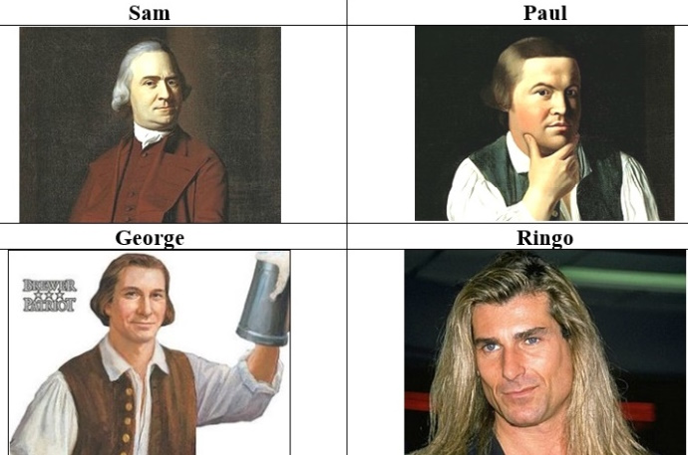
Absolutely Fabiolous
Before we get to the short bio of Sam Adams, it seems appropriate to answer the real question everybody seems to have about Sam: Did he brew beer? Yes. The small brewery Sam inherited from his father failed for lack of commitment due to Sam’s real love, politics. But that was no reason for Jim Koch, founder of the Boston Beer Company (est. 1984), to not name his signature beer after the patriot.
Using a recipe his great-great grandfather, Louis Koch, created in 1860, Koch went with the name Samuel Adams, feeling that just as Sam had spawned a political revolution by taking on the political powers-that-be, Koch would set out to create a revolution in beer brewing to take on what he felt was a stagnant, unimaginative beer market dominated by a handful of large brewers.
Koch’s vision was almost immediately successful, spearheading the now-robust microbrew industry and still remains the dominant microbrewery in the US.
But when it came to deciding on a beer label logo, apparently Sam’s personal appearance was deemed in need of improvement. The image of Sam considered most realistic was painted by John Singleton Copley and while I would agree with others that have asserted that Sam would not win any “hunk” contest, I will, however, dispute those tour guides, both oral and written, that label Sam as “real ugly” “hideous” etc. The label’s logo image does, as some contend, look very much like Paul Revere, again through the paintbrush of John Singleton Copley.
But in my opinion the persona of the Boston Beer Co.’s Sam Adams logo looks most like is Fabio of romance novel cover art fame! So if you order a Sam Adams beer make sure to get a bottle and see if you agree that the label’s image is indeed Absolutely Fabiolous!

