Ad-Clad
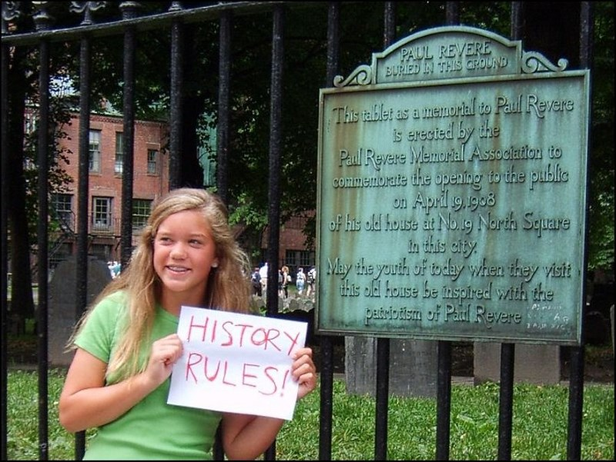
As the old Warner Brothers cartoon saying goes, “That’s All Folks!” I hope you enjoyed your visit here at the Old Granary. Feel free to visit my website (historybuddy.com) where you can download an exact copy of this guide in electronic form (pdf) for free. I am currently adding a variety of Boston historical-related content to enhance your next visit here in “Beantown”.

That being said, I would like to wish you a wonderful rest of your stay here in Boston and safe travels back to your corner of the world.

