Peter Faneuil (1700-1743)
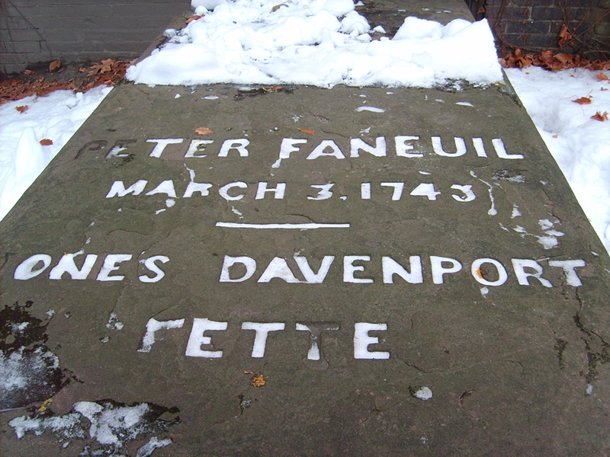
Peter Faneuil's father died when he was 18 and his wealthy uncle, one Andrew Faneuil, a prominent merchant whose ships called at ports around the Atlantic, adopted Peter. When Andrew died Peter inherited his uncle's fortune but only after agreeing to one provision: like Andrew he had to remain a bachelor. Peter honored his uncle's wishes naming one of his ships the "Jolly Bachelor" and indeed he was, entertaining with lavish dinners nightly at his stately home.

In 1742 he donated the funds for the construction of Faneuil Hall. But only a few months after the completion of this venerable building Faneuil would live up to his ship's name, dying of "too much good living."

Jimmy’s Tangents:

• The vote to accept Peter's offer to fund his central market passed with a vote of 367-360 but only after Peter offers to also build a second floor to house a town meeting hall
• This arrangement of town hall above and food market below inspired Francis Hatch to write in 1958: "Here orators in ages past / Have mounted their attacks / Undaunted by proximity / Of sausage on the racks."
• Brother Benjamin, first in line for Uncle Andrew's fortune but forfeited when he got married, inherited Peter's fortune, proving that sometimes you can have your cake and eat it too.
• The original 1742 grasshopper weathervane by Sheme Drowne still graces Faneuil Hall
• In 1974 the grasshopper was stolen and eventually found five days later hidden under flags in the building’s cupola but not before 28 other previously stolen weathervanes were recovered by authorities.
• The Boston police officer that cracked the case? - The patriotically-named Detective Paul Revere Carroll.

