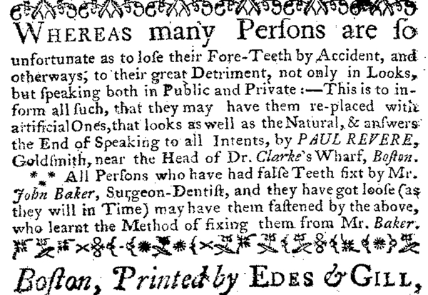
CSI Revere
Revere’s side occupation of dentistry led him to being involved in what has been deemed one of the earliest examples of forensics techniques used to identify a buried, decomposed body.
General Joseph Warren had died at the Battle of Bunker Hill and was buried in a mass grave along with numerous colonial soldiers that had also fallen in the battle. Revere noted prior to the search and eventual excavation of Warren’s body the details of a dental plate that he had made for Warren.
When the body believed to be Warren’s was located and exhumed, the dental plate Revere had described was indeed found to match Revere’s description (with Revere himself making a visual identification.)
Warren was subsequently briefly buried in a tomb here at the Granary, then moved to a crypt down Tremont Street at St. Paul’s church and eventually moved one more time to his final resting place in Forest Hills Cemetery, a few miles away.

