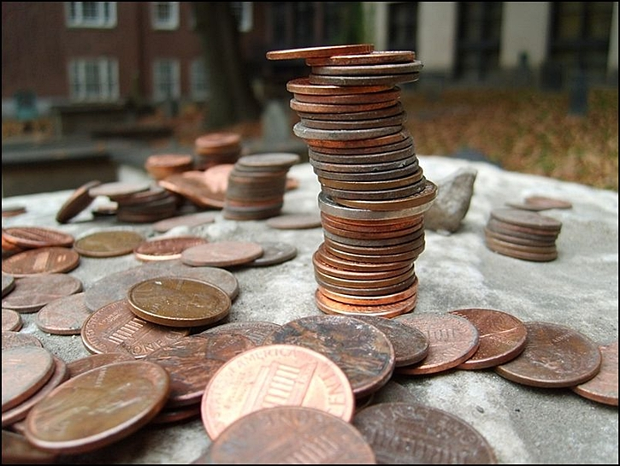
Copper Toppers
So what’s the deal with stones and coins on top of some graves?

Unless you are visiting immediately after a periodical Parks Dept. cleanup, chances are you will see stones and coins placed on graves, primarily people of renown. So what’s the deal? From what I have been able to discover, leaving a stone is a Jewish tradition called Mitzvah of Matzevah (“setting of stone”) that grew out of the early funeral tradition that involved the body of the deceased being buried and each mourner placing a small stone on top to create a cairn. The cairn not only marked the grave (particularly necessary when their Jewish brethren were buried in the desert) but also protected the mortal remains from hungry animals.

Today that tradition plays out more in the form of each pebble or stone being, in essence, a calling card of respect. Paul Revere, Sam Adams, John Hancock are not Jewish so the tradition has clearly evolved into a secular one and today is more of an exercise in mimicking than being in-the-know, with kids generally at the forefront of the effort.

As to the coins: When visiting Ben Franklin’s grave at Christ Church in Philadelphia the tradition is to leave a penny, presumably due to Ben’s “A penny saved is a penny earned” advice. If any one person had a tradition created just to honor them (and then copied) it would be Ben. Another reason could be the mimicking of the ancient tradition of placing gold coins with the deceased to pay the toll charged by Charon, the boatman of the Underworld, for passage to the other side of the river Styx; reputedly to not do so was to condemn the deceased to wander the shores for eternity and thus never find peace. There is a very slim chance that some place pennies on Paul Revere’s grave to reflect his work in engraving in copper, most famously his 1770 Boston Massacre print. In the end I believe that people mostly place coins, just like the stones, as a form of good-willed mimicry.

