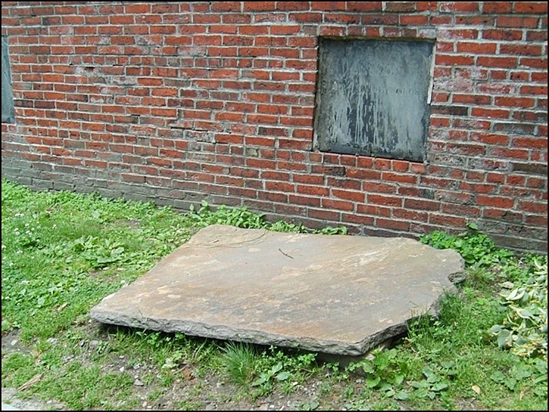
Dr. Granary
If you continue up the path you will come to Tomb 96; take notice of the large slab of stone on the ground. While this flat stone indeed hides a hole that leads into the tomb, in February of 2007 it also hid $10,000.
That’s because a large coin five inches in diameter in a black pouch was hidden under the slab's back edge. Finding the hidden coin and winning the money prize was to have been the reward for figuring out the 30th, and final, clue to a country-wide historical trivia contest “Hunt For More” sponsored by the makers of the Dr. Pepper soft drink: “You're hot on the trail, though the place may feel chilly. The coin rests by the name of a patriot at rest in Philly.” I’ll give you a minute to guess the answer.
The clue was released via the Internet at 3 AM and within a half-hour the front fence along Tremont Street was lined with eager treasure hunters. Boston Park Rangers arrived at their Boston Common headquarters around 6 AM only to find themselves inundated by angry cell phone calls from treasure hunters complaining that the burial ground was still closed.
It was quickly determined that not only would the Granary not be opened to protect against any damage that a small army of treasure hunters digging through every nook and cranny might inflict, but local police needed to be alerted so that they could protect the graveyard from any overzealous participant that decided to simply take the next step and trespass.

Dr. Pepper officials cancelled the Boston portion of the contest, donated the $10,000 to a local charity, agreed to pay for the extra police detail, and vowed to never include Boston in any future contests without the full knowledge and approval of city officials.

Oh, I almost forgot. The chilly Philly patriot? Mr. $100 bill himself - Ben Franklin.

