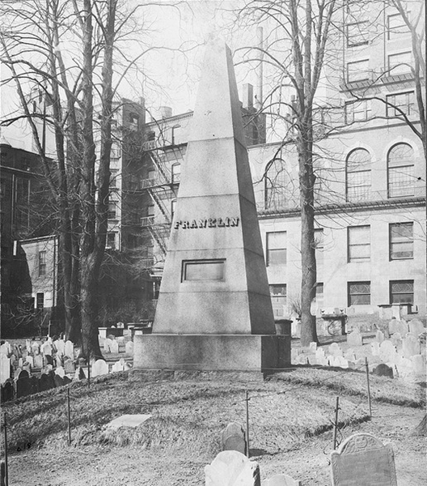
JOSIAH AND ABIAH FRANKLIN

Parents of the world-famous Benjamin Franklin, Josiah and Abiah Franklin's family tomb is marked by this 21-foot stone obelisk which was donated by a group of citizens in 1827 when the original marker fell into deep decay. Both Josiah and Abiah ran a soap-and-candle business and it was in the home above the shop that Ben and his twelve other brothers and sisters grew up. Ben only lived in Boston until he was sixteen, moving to Philadelphia after he quit his job as his brother James' printing apprentice, citing both verbal and physical abuse. Ben went on to spend the majority of his very productive adult life in the "City of Brotherly Love" and is buried there. The loving inscription on the monument, the text of which follows, is from the pen of none other than Ben Franklin himself:

JOSIAH FRANKLIN AND ABIAH HIS WIFE LIE HERE INTERRED THEY LIVED LOVINGLY TOGETHER IN WEDLOCK FIFTY-FIVE YEARS. AND WITHOUT AN ESTATE OR ANY GAINFUL EMPLOYMENT, BY CONSTANT LABOR AND HONEST INDUSTRY, MAINTAINED A LARGE FAMILY COMFORTABLY, AND BROUGHT UP THIRTEEN CHILDREN AND SEVEN GRANDCHILDREN, RESPECTABLY.
FROM THIS INSTANCE READER, BE ENCOURAGED TO DILIGENCE IN THY CALLING, AND DISTRUST NOT PROVIDENCE. HE WAS A PIOUS AND PRUDENT MAN; SHE A DISCREET AND VIRTUOUS WOMAN.
THEIR YOUNGEST SON, IN FILIAL REGARD TO THEIR MEMORY PLACES THIS STONE
J.F. BORN 1655, ___ DIED 1744, AE. 89.
A.F. ______1667, _______1752 ___85 .

THE ORIGINAL INSCRIPTION HAVING BEEN NEARLY OBLITERATED A NUMBER OF CITIZENS ERECTED THIS MONUMENT AS A MARK OF RESPECT FOR THE ILLUSTRIOUS AUTHOR

Jimmy’s Tangents:

• The 1827 Franklin Monument was designed by Solomon Willard of Bunker Hill Monument fame; he also designed the Egyptian-revival entrance in 1840
• Ben was born on Milk Street across from the Old South Meeting House (look for an embedded bust of Ben)
• Mark Twain mentioned how on one visit he had the chance to see two places where Ben Franklin was born adding he would have seen more but he was only in town for the afternoon
• Ben's statue stands on the original site of America's first public school, Boston Latin
• He is the school's most famous dropout
• Ben's brother James established the first truly independent newspaper, The New England Courant
• Ben's statue was the first portrait statue in Boston and can be seen standing in front of Old City Hall
• Sculptor William Greenough revealed that he purposely made the 1855 statue so that the right side of Ben’s mouth reflects the serious Ben of diplomacy, science and political theory and the left side the satirical Ben of Mrs. Silence Dogood and Poor Richard's Almanac

