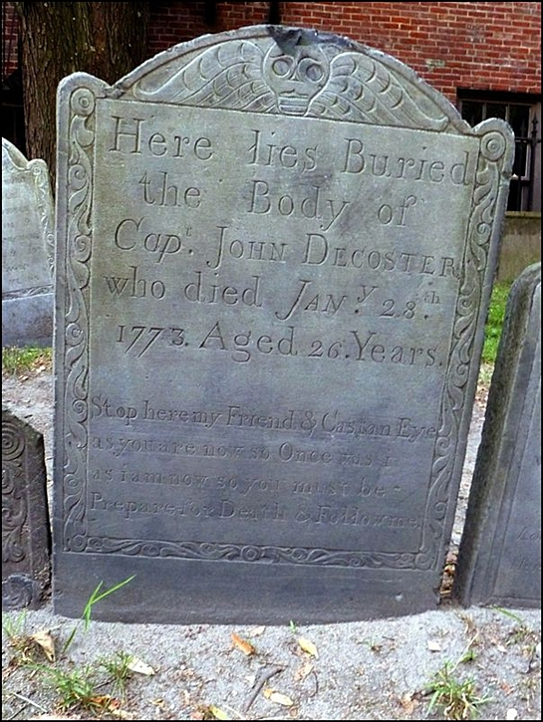
Graveitational Pull
Now before we toodle over to the Hancock Memorial let me just mention the poetic headstone of Cap. John Decoster. His marker is easy enough to find. Looking straight at the “Sod Couple” from the walkway you should be standing in front of the headstone for one Waitstill Trott. Two headstones to the right you’ll find the late Cap.’s stone. Below the standard info of his name, year of death, etc. is a short poem that you may have heard some rendition of before, reputedly scribed by a 12th century English prince. Decoster’s version reads:
“Stop here, my Friends, and Cast an eye / As you are now, so Once was I / As I am now, so you must be / Prepare for Death and Follow me.”
It seems to me the right retort to Decoster’s grave invitation would be:
“To follow you I will not consent / Until I know which way you went!”

