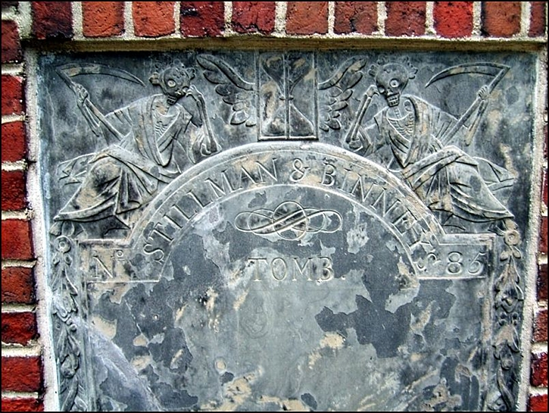
Grim Peepers
As you make your way towards the tomb of Robert Treat Paine, I would like to introduce you to my favorite bit of funereal art here at the Granary: the Stillman & Binney Tomb (#85).
As you can see for yourself the tomb’s slate marker features two Grim Reapers, both propping their upper bodies (well, skeletons) with their arms and looking both bored and disgusted.
Since this tomb, like most, was built by an owner before their death, the Grim Reapers’ disposition seems to indicate an attitude of, “OK guys. We know you built this tomb ahead of your demise and, well, it’s a very nice one at that. But could you die already? See we’ve got places to go, bodies to retrieve… LOOK, WE DON’T HAVE ETERNITY! Uh…well…ok we DO have eternity but…OH, JUST DIE ALREADY!” (/sillyness)

