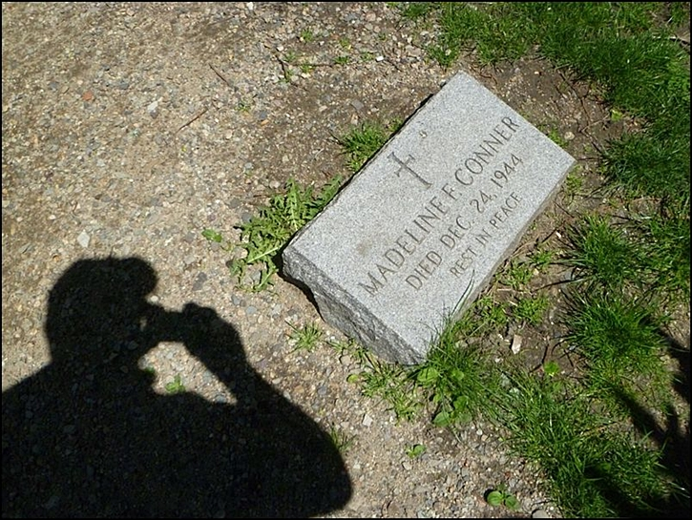
Guest of Conner?
If you turn towards Tremont Street, placing Sam Adams directly behind you, you will see across the path a relatively new granite gravestone with the name Madeline F. Conner.
In 1985 the city-funded Historic Burying Ground Initiative (HBGI) did a survey of all sixteen burial grounds located in Boston proper. This included a recording of each and every headstone and tomb’s pertinent information (epitaph, condition, material, location) as well as identifying candidates for repair, improving & expanding pathways and updating information markers.
Now if one were to look up the pertinent information recorded by the HBGI in regard to the grave of Madeline F. Conner one would encounter a mountain of…nothing. That’s because this headstone wasn’t there in 1985.
This wouldn’t be a surprise since technically burials in tombs ended in 1879 (reserved) and open ground burials (unreserved) even earlier. There seem to have been some exceptions for tomb burials since 1879 (look for Rhys Williams’ 2003 headstone near John Winthrop’s tomb at King’s Chapel Burial Ground) but that involved the deceased’s remains having been cremated.
To add to the mystery is that Madeline Conner supposedly died on Christmas Eve 1944, forty-one years before the 1985 survey.
Whether Madeline Conner was actually buried here in a tomb back in 1944, moved here after 1985, not buried here at all or (fill in the blank) remains unanswered, as well as who was responsible for placing the stone here.

