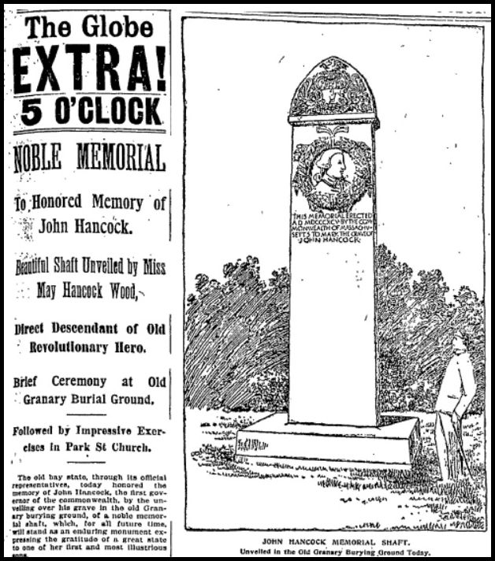
Handle With Stare
Boston Globe front page article, September 10, 1895
To address the elephant in the room (adults only):
Yes, as many noted to me, the Hancock memorial does indeed seem to have a somewhat phallic appearance. While I don’t believe it is an intentional slight towards Hancock (but if true would be unfair), I must admit that some of the word choices in the headlines of this article (shaft, Wood, brief, impressive exercises) seem to unintentionally support the theme.

