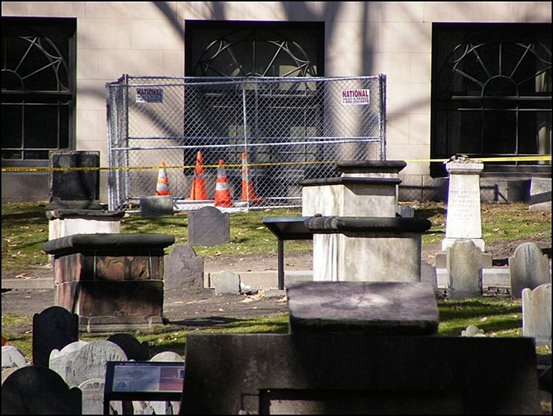
Hole Down Dance
Due to popular inquiry - In late January of 2009 a woman was poking around some graves a few yards behind Paul Revere’s tomb when she “discovered” – up to her hips – a long-covered entry to what is now believed to be the tomb of Jonathan Armitage, a former town selectman in the early 1700’s (Boston was granted a city charter in 1822).
Apparently in wandering off the beaten path she had stepped directly onto a large slab of slate placed flush in the ground to cover the tomb’s entry when the slab gave way, courteously breaking in two. The woman was not injured but the burial ground was briefly closed due to repairs.
The old, broken slab of stone has since been replaced with a new, unbroken one and is scheduled to break, due to a wandering tourist, in the year 2287 (“Dear Parks Dept: just kidding!”)
BTW, the replacement slab was covered with dirt and is now hidden again under a fresh patch of grass so there is no trace of the “Hole Down Dance”.

