JOHN HANCOCK (1737-1793)
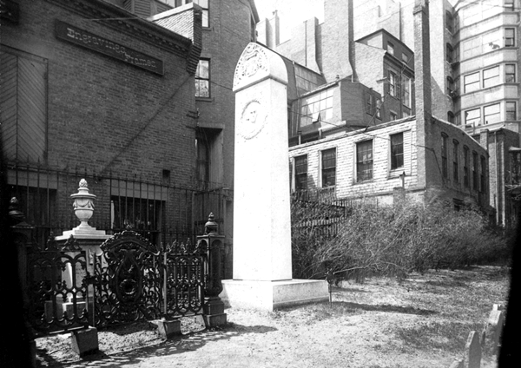
A merchant, public official, and first signer of the Declaration of Independence, Hancock was born in Braintree, Massachusetts. When he was a child John’s father died and he was subsequently raised by his Uncle Thomas at his estate on nearby Beacon Hill and eventually graduated from Harvard. After inheriting his uncle’s mercantile firm in 1764 Hancock became the richest Bostonian of his time.

As a businessman Hancock was brought into the fray over the Stamp Act and other British commercial policies. Fostering a spirit of defiance, he named one of his newest ships Liberty to openly challenge the trade regulations.
With an estimated 1,000 citizens dependent upon his business, several riots erupted when the Liberty was seized by customs officials for allegedly lacking to declare all products on board for customs duties to be paid.

Soon thereafter, with the support of Samuel Adams, Hancock was elected to a seat in the Massachusetts House legislature. He was a delegate to both Continental Congresses and, as President of the second, was the first to boldly sign the Declaration of Independence, large enough so that King George III could recognize Hancock’s signature without the use of his reading glasses.

After the war he helped draft the Massachusetts constitution and was elected the state’s first governor. His political instincts led him to abruptly resign as Governor in 1785, leaving newly minted Governor James Bowdoin to deal with the brief but potent “Shay’s Rebellion.” In 1787 he returned to the Governorship and died on October 6, 1793 at the age of 56 while serving his ninth yearly term as governor.

Jimmy’s Tangents:
• On a grand tour of all thirteen colonies shortly after being elected to his first Presidential term, George Washington nearly refused to enter town when Hancock, the reigning governor, was not among the welcoming party. Hancock felt that as the chief executive of the state Washington should greet him. It took all the persuasive powers of Sam Adams and then-Vice President John Adams to get
Washington to continue along.
• Hancock quickly realized his mistake, paid a visit to Washington’s lodgings the next day wrapped with an extensive collection of bandages and claiming a horrible case of gout. Washington, upon seeing his old Revolutionary cohort in such a state, and reportedly with a tear in his eye, accepted Hancock’s invitation for tea the next day at Hancock’s Beacon Hill mansion where all was forgiven.
• Hancock displayed an effective advocacy for the rights of African Americans: he attested to the Royal Governor on behalf
of Phillis Wheatley’s authorship of her Poems On Various Subjects, Both Religious And Moral (as did Sam Adams) in 1773; he supported the formation of an all-black military company, The Bucks of America, in 1775; and he supported the ratification of the 1781 Mass. Constitution and it’s implied outlawing of slavery (legally settled in 1783)
• Up until 1895 the only evidence of Hancock’s burial here at the Granary was a slate slab placed flush in the ground that simply read "Hancock - Tomb 16”
• The Massachusetts Legislature
resolution that led to the creation of the current 18-foot granite memorial was sponsored by a black legislator named Robert Teamoh
• On the Hancock coat-of-arms, the Latin phrase, “Obsta Principiis” has several
translations: “First In Resistance”; “Resist the First Encroachments”; or the somewhat more contemporary, “Nip It In The Bud”
• Abiah Holbrook, the writing teacher that taught Hancock the art of penmanship at the South Writing School, also “resides” here at the Granary
• The New State House (only in Boston would a 1798 building be called “New”) is built on Hancock’s former land
• The former Hancock mansion lost a last chance at survival in 1863 when a state legislature motion to preserve the house as a historical artifact lost by a single vote; the loss so outraged the local populace that efforts to preserve the Old South Meeting House (1872) and the Old State House (1881) became overwhelming successes
• The 1947 Hancock Building in the Back Bay district houses a neon-lit weather beacon that still uses color codes to announce future weather: “Steady blue, clear view; flashing blue, clouds are due; steady red, rain ahead; flashing red, snow instead”
• During the Red Sox’s baseball season the flashing red indicates that the game at Fenway has been rained out
• In 1976 the brand-new John Hancock Tower, at 790 feet New England’s tallest structure, had to have all 10,344 windows replaced when the lead solder holding together each double-paned sheet of glass became brittle and didn’t allow for any natural sway during periods of strong winds (it was nicknamed “The Plywood Palace”)
• Also due to wind concerns two 300-ton steel-lined lead “dampers” had to be placed on opposite ends of the 58th floor, each resting on lubricated steel plates. Ingeniously designed by William LeMessurierhen, the custom designed springs and shock absorbers, in combination with the lubricated steel plates, make the 300-ton dampers actually remain in place while the building “surfs” underneath (only a few inches each way!)

