SAMUEL ADAMS (1722-1803)
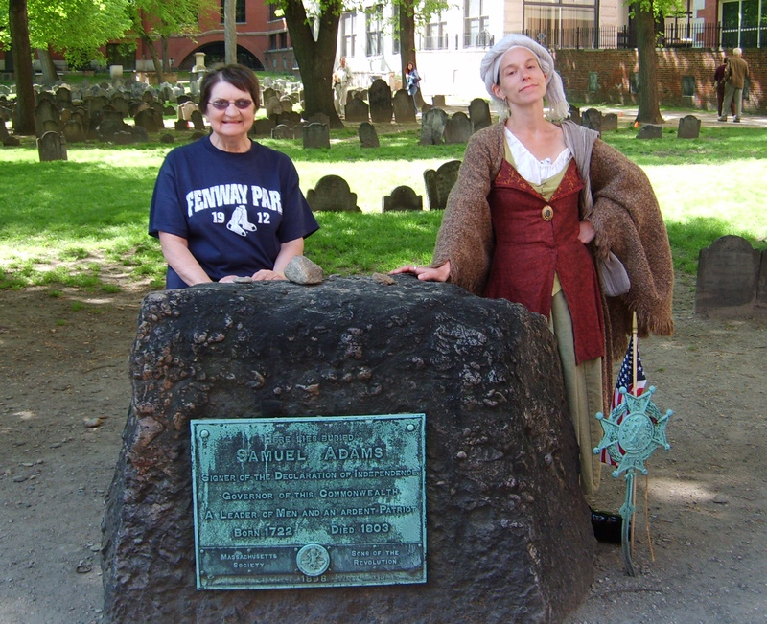
"What do we mean by the Revolution? The war? That was no part of the Revolution. It was only an effect and a consequence of it. The Revolution was in the minds of the people, and this was effected, from 1760 to 1775, in the course of fifteen years before a drop of blood was drawn at Lexington."
- John Adams to Thomas Jefferson, 1818

“If ye love wealth greater than liberty, the tranquility of servitude greater than the animating contest for freedom, go home from us in peace. We seek not your counsel, nor your arms. Crouch down and lick the hand that feeds you; May your chains set lightly upon you, and may posterity forget that ye were our countrymen.”

-Samuel Adams, Continental Congress, Philadelphia, 1776

The second cousin of President John Adams, Samuel Adams is best known for his role as the Organizer of the Revolution. After failing as an owner of a beer brewery and as a tax collector - he proved too lenient when it came to collecting taxes from the poor - he finally found his calling as a political leader.
Harvard-educated, he gained his political base by mastering the town meeting where he was the first to reason that being ruled by a government a month's sail away would inevitably fail. He was the main strategist for the patriots, calling their every move against every new Crown policy.

Adams was the first to make fun of himself and his traditional bland Puritan clothing, an attribute that was immeasurable in winning over the local townspeople whom he would meet every day as he made his rounds to the local taverns and shipyards.
Cousin John described him as:
"...a man of refined policy, steadfast integrity, exquisite humanity, obliging, engaging manners, real as well as professed (poverty), and a universal good character, unless it should be admitted that he is too attentive to the public and not enough to himself and his family."

Adams led demonstrations against all Crown policies, created the Committee of Correspondence that led to the uniting of the other twelve colonies into a coordinated effort of protest and was the mastermind behind the Boston Tea Party.
Adams was a member of both Continental Congresses and was a signer of the Declaration of Independence. After the war, Adams served as Lieutenant Governor and Governor of Massachusetts and was instrumental in getting the ratification of the U.S. Constitution. He died in Boston on October 2, 1803.

Jimmy’s Tangents:
• Sam Adams’ 1740 Harvard thesis could not have been more foreboding:
"Whether it be Lawful to resist the Supreme Magistrate, if the Commonwealth cannot otherwise be preserved."
• The emblem that is placed on every police car in Lexington contains the words Sam Adams spoke when he first heard of the Battle of Lexington: “What a glorious morning for America!”
• #1 Trolley Tour joke: “The Beantown Pub (directly across the street) is the only pub in the world where you can drink a cold Sam Adams…while looking at a cold Sam Adams!”

