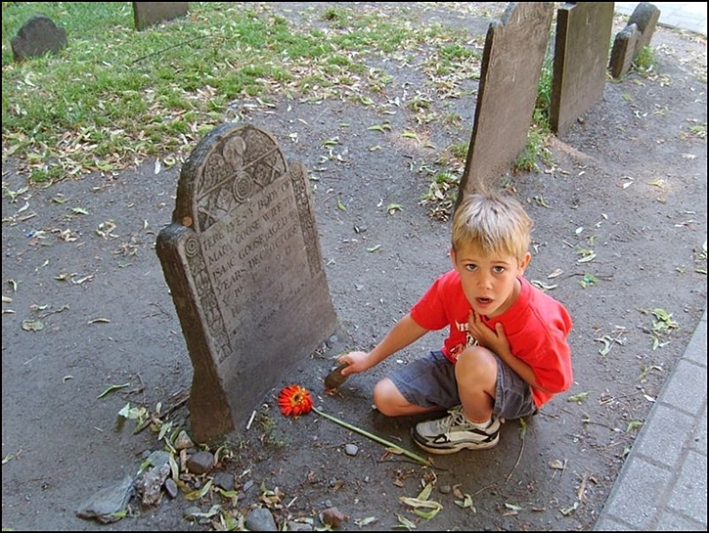
BOSTON'S MOTHER GOOSE
Elizabeth Goose, who died in 1757, was the second wife of Isaac Goose. She raised 20 children - ten by Isaac's first wife Mary - and ten of her own. Legend has it that her son-in-law, Thomas Fleet, a book dealer and printer, published a book of stories titled, Songs for the Nursery or Mother Goose's Melodies.
Since no copies have ever been found the legend remains unproved. The fact that the pen name "Mother Goose" was in use in England before Elizabeth's birth also casts doubt on any claims that she was indeed Mother Goose.

Unfortunately, Elizabeth's gravestone disappeared long ago. But you can still see a marker for Isaac's first wife, Mary.
Jimmy’s Tangents:

• Robert McCloskey's 1941 award-winning children's book, Make Way For Ducklings, is based in Boston
• Artist Nancy Schon created a collection of nine statues representing Mrs. Mallard and her eight ducklings:
Jack, Kack, Lack, Mack, Nack, Ouack, Pack, and Quack
• The statues can be found in the Public Garden and are easy to find - just look for kids of all ages engaged in joyous, rollicking play as they ride the loveable little ducklings

