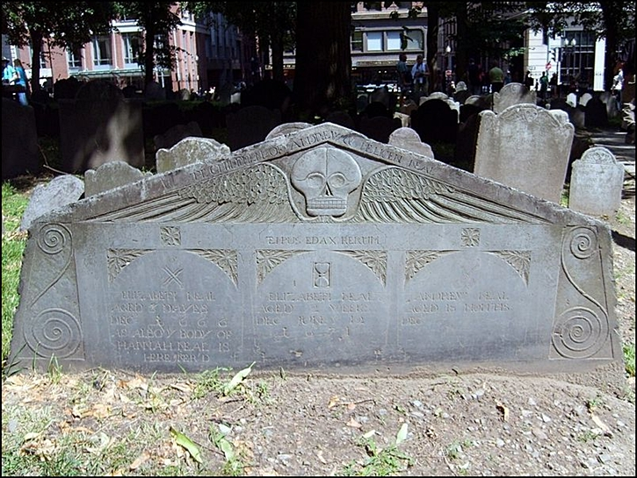
Neal & Pray
As you make your way towards Mother Goose you may want to check out one of my favorite headstones located on the right-hand side of the path, the wide, pentagon-shaped slate slab dedicated to the young deaths of the children of Andrew and Melicent Neal. The 1666 date is the oldest to be seen on any stone here in the Granary (you’ll see the actual oldest headstone shortly) and notes the age of deaths ranging from the first Elizabeth’s of three days to the passing of Andrew at eighteen months.

This grave is one of my favorites because of all the details done by the anonymous carver: the classic winged, death head; the curly-cue reliefs that look very much like a modern Clef musical notation; the Latin inscription, TEMPUS EDAX RERUM (“Time, devourer of all things”) But what I love the most is the three small symbols etched into the stone above the inscribed names: the crossbones, the hourglass and, my favorite, the two little criss-crossed shovels.

