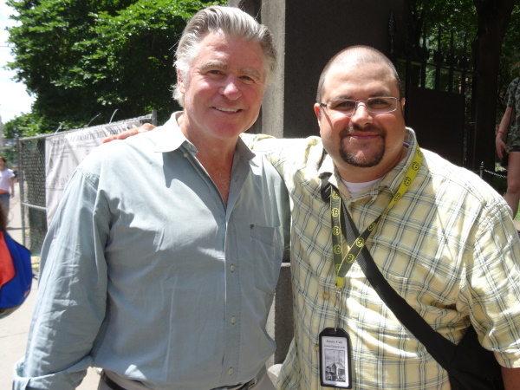

No Tricks, All Treat
On March 7th of 2014, it was a blustery Friday and I was at my usual post on Tremont Street when this gentleman, like yourself, accepted the offer of the use of my guide.
During some polite conversation he revealed to me that he was temporarily working in town for a few weeks and had some downtime and decided it was an opportune chance to pay respects to an ancestor buried here at the Granary. I asked him of whom he was related and he replied, “Robert Treat Paine.” I replied, “Cool. One of the three signers of the Declaration of Independence buried here.” I then quickly explained where he could find him and off he went.
About ten minutes later the gentleman returned and thanked me for the use of my guide and that he had indeed found his ancestor. Then the following exchange occurred:

Me: “Since you are related, sir, I’m not sure if you noticed it in my “Jimmy’s Tangents" section for Mr. Paine but, according to Wikipedia.org, actor Treat Williams is reputedly a descendent and namesake of Robert Treat Paine.”

Gentleman: “I’m Treat Williams.”

Me: “Oh… well…that’s cool…but I mean the actor Treat Williams.”

Gentleman: “I’m the actor Treat Williams!”

Me: “Oh…(reality finally registers) OHHH!!!”

We both had a good laugh and I mentioned how much I enjoyed the 1979 Spielberg-directed movie, 1941, that Treat starred in and how it was a classic case of a great movie that, while having been initially panned by critics, truly has stood the test of time and is a romping bit of fun. For a guy with a solid national profile after forty years in the competitive acting business- Hair, Prince of the City, Once Upon A Time In America, A Streetcar Named Desire, Everwood, 126 others! (according to IMDB) - Treat was super nice and offered to take a photo of us together (with the help of a fellow Bostonian’s hands) and posted it on his Twitter feed.
A few months later, at the height of the summer season, Treat made a surprise return, bringing along his lovely wife Pam. I showed him a quick glimpse of the write-up I had made and had him take a photo of the front page with the link to download my full guide (sound familiar?) and then I proceeded to describe to Pam the goofy scenario written here, except in this live, oral version, when I said Treat's name, I would also point at him for full silly effect. We all laughed heartily and, once again, Treat offered a photo, this time Pam doing the snapshot honors.
After our good-byes, I realized that I once again had missed an opportunity to get a photo of Treat and his namesake together. Minor regret aside, it’s nice to be able to confirm that Treat's reputation as a classy, down to earth guy is well deserved. As my punny title says, “No Tricks, All Treat.”

