VICTIMS OF THE
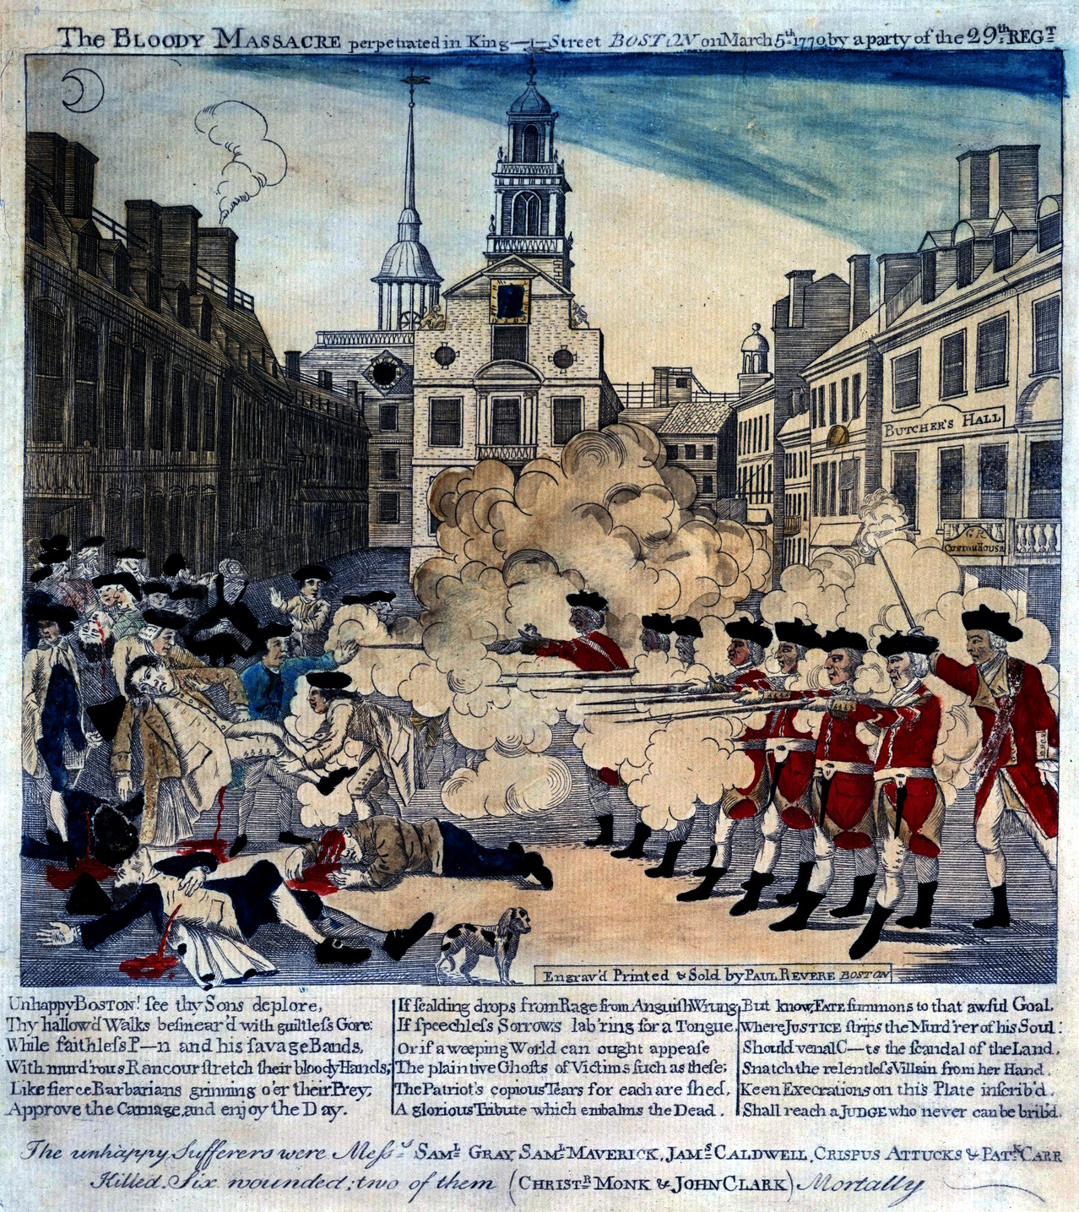
BOSTON MASSACRE
On October 1, 1768, British redcoats arrived in Boston, sent by King George III to restore order after several Royal customs officials were beaten following the seizure of John Hancock's ship, Liberty, for smuggling to avoid paying the required duties. For the next 18 months the town’s people and the soldiers lived in an increasingly charged atmosphere as taunts, name-calling and scuffles marked the daily life of the town.
To make matters worse the local economy was in a deep recession and local unemployed workers found themselves in competition with off-duty soldiers for jobs in Boston's tight labor market.

After 12 year-old Christopher Snider was killed by a loyalist in an anti-customs riot eleven days earlier, the climax came on the cold, snowy evening of March 5, 1770. There had been several skirmishes with soldiers that day and the word on the street was that that night there would be more trouble.

Around nine p.m. an angry crowd of townspeople cornered a lone sentry outside the Custom House within the shadow of the Old State House. When someone rang a nearby church bell - normally used to warn of a fire - several hundred more arrived, many armed with clubs and sticks. When the cornered sentry's cry for help brought Captain William Preston and a file of eight armed soldiers to the rescue, the crowd surrounded them and prevented their return to the guardhouse.
For the next fifteen minutes the crowd grew uglier, daring the soldiers to fire, cursing them, pressing closer and closer. Snowballs and rocks flew through the air. The fuse was finally lit when a thrown club hit one of the soldiers knocking him to the ground. The injured soldier stood up and fired at point-blank range. The other soldiers, confused and in fear of their lives, followed suit.

Captain Preston frantically ordered his men to cease-fire, but the damage was done. Three died immediately. One died the next morning. The fifth victim would die several days later.
The slain men were a cross-section of Boston. The first to fall, Crispus Attucks, was black; another, Patrick Carr, was Irish. Samuel Gray, Samuel Maverick and James Caldwell were all apprentices to local craftsmen.

Samuel Adams labeled the incident the "Bloody Massacre" and used it to force the removal of the troops to Castle Island in the harbor ending a two-year occupation. Paul Revere made a famous engraving of the episode that, although factually inaccurate, was great propaganda. Copies of it were sold throughout the town and carried all over the colonies as well as back to England. A few days later an elaborate funeral organized by Samuel Adams drew thousands of angry mourners here to the Old Granary Burying Ground.

Future president John Adams and Josiah Quincy bravely risked their patriot reputations by defending Captain Preston and the eight soldiers in the subsequent trials. They won acquittals for all but two of the soldiers.
Found guilty of manslaughter the two soldiers pleaded benefit of clergy that allowed them to read or write a verse of Scripture and forego prison. To ensure that benefit of clergy could only be used once the two guilty soldiers each had a thumb branded with the letter M for manslaughter.
Jimmy’s Tangents:

• The famous engraving that Revere made was a copy of one done by a younger Henry Pelham; Revere was simply faster at getting his copy to press to the chagrin of Pelham (all eventually forgiven)
• Edward Palmer built the first town stocks in Boston on the future site of the Boston Massacre and became the first placed in them.
His offense? Overcharging for his services!
• On July 11, 1976, Queen Elizabeth made a tour of all the major revolutionary sites including the Old State House and the site of the Boston Massacre
• The Queen noted that since she was the great-great-great-great granddaughter of King George III, Paul Revere, Sam Adams and other Revolutionaries of the time might be surprised at her Royal presence. Then, with a grin, added, "But perhaps they would have been pleased."

