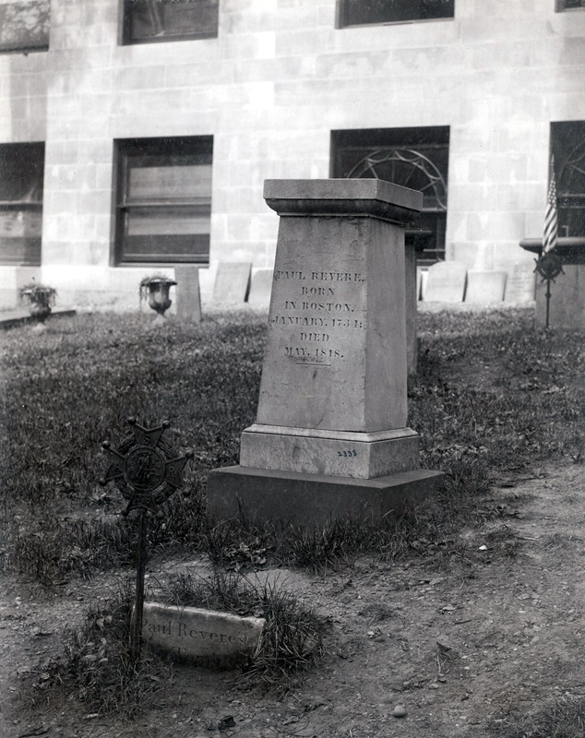
Paul’s In Stead?
While browsing through the Flickr photo archives of the Boston Public Library (BPL) I came upon this amazing 1898 photo, which managed to confirm a nagging suspicion I have had on my mind for over twenty years. Since the image cannot be duplicated with true detailed justice by a mono laser printer, I have provided an internet link, via the QR code, to the photo in its full resolution glory.

In the photo you can see the larger 1885 public subscription monument and in front of it a smaller, straight-edged object protruding from the ground roughly where you see the granite curb installed today. The smaller object reads: “Paul Revere’s Tomb” and after a quick comparison (size, shape, type of stone, etc.) it became apparent to me that it was not the same small, rounded tombstone you see embedded a few feet to the right today.
Thus it is unfortunately clear now, due to this photo, that the small tombstone seen today is a replacement. Of the limited info I could recently dig up, it appears that the placement of the current headstone probably occurred in the early 1970’s when the semi-circular standing area was created.

After tossing all of this physical evidence around in my noggin for a little while, it finally hit me what had been the cause of the nagging suspicion I have had had all these years about the tombstone to be seen today – the simple inscription.
For years I had a “Jimmy’s Tangents” listing that said Revere reputedly got his headstone as a gag gift when he was much younger but that it had indeed become his tombstone. While I only had one source for that story it made sense to me at the time because it was the only way to explain the current marker’s presumptive inscription.
On the older tombstone in the photo the inscription reads “Paul Revere’s Tomb.” For whom is this tombstone? Revere. Which Revere? Paul. And yet the “Revere’s Tomb” etching on the current marker clearly presumes that the viewer will know which Revere.
This fantastic photo, while creating a few new questions to be answered, at least puts to rest the notion that the current smaller marker is Paul Revere’s original tombstone.

