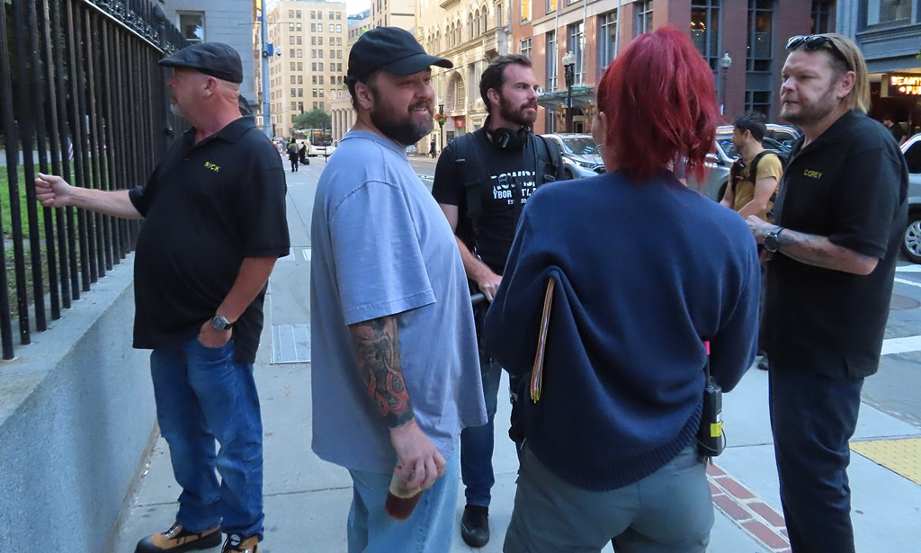
Pawn of the Dead
On August 2, 2023, for about an hour, the Granary became Beantown Vegas when the cast and crew of the popular History Channel show, Pawn Stars, filmed some brief scenes here. As jam-packed as my guide already is, I was able to do a little consolidating to add the following pix. To get the whole colorized scoop, I put together two slideshows: one 2-minute version with music background – the other longer and narrated.

