PAUL REVERE (1734-1818)
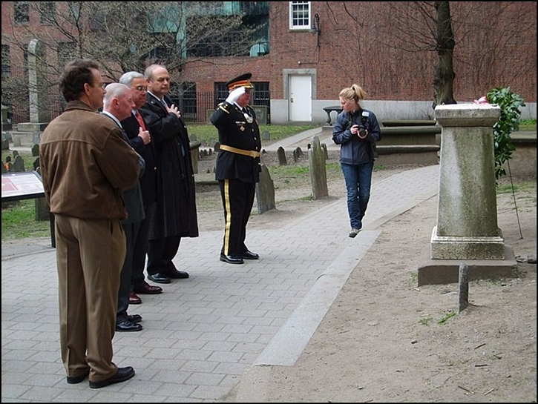
A revolutionary patriot and noted American silversmith, Revere was born in Boston, the son of French Huguenots. Revere became a celebrated silversmith, considered by many to having been the best of his time. Paul was also a goldsmith, made copper engravings, surgical instruments, dental plates and political cartoons for the patriot cause.
Revere's knowledge of the feelings of the average working man and his ties with them were instrumental in developing grass roots support for the Revolution.
In 1770 he created the famous engraving of the "Boston Massacre," became a leader of the Sons of Liberty and helped organize the Boston Tea Party. After only getting a couple hours of sleep, Revere carried news of the Boston Tea Party to New York City and Philadelphia and by the opening shots of the Revolutionary War he was a respected figure throughout the colonies having logged thousands of miles to inform of Boston's latest political move.

Revere is most famous for his ride from Boston to Lexington to warn John Hancock and Samuel Adams that the British troops intended to arrest them and seize military supplies that had been stored by local minuteman in Concord. Along the way he alerted the Middlesex County minuteman of the impending arrival of the British troops. Poet Henry Wadsworth Longfellow immortalized the event in his 1861 poem, “The Midnight Ride of Paul Revere.”

During the latter part of the war Revere served as an officer and engraved the first Continental money and the official Massachusetts seal.

After the war Revere set up a foundry and manufactured gunpowder, copper balls, cannons, stoves, and numerous church bells many of which are still rung today in steeples throughout New England. Revere invented a method to roll copper and, using the process, sheathed the dome of the new State House on Beacon Hill and the bottom of Old Ironsides, the U.S.S. Constitution.
Jimmy’s Tangents:
• Henry Wadsworth Longfellow was inspired to write his poem, The Midnight Ride of Paul Revere, while visiting Old North Church on the 85th anniversary of the event (1860)
• First published in the January 1861 edition of The Atlantic Monthly magazine it was an effort to inspire Americans to the Union Cause by highlighting the fact that one person can make a difference
• Poem Inaccuracy #1: the signals were not to Revere but from Revere to fellow Patriots on the Charlestown side of the bay in case Revere was captured crossing
• Poem Inaccuracy #2: Revere surely did not say, "The British are coming! The British are coming!" because Revere and all others were still British subjects at the time
• He more likely said: "The Regulars are coming!" or “The Lobsterbacks are coming!”
• Poem inaccuracy #3: Although Revere and fellow rider William "Billy" Dawes (Dawes took the longer land route) did reach Lexington to warn Sam Adams and John Hancock that the Regulars were on their way, neither rider completed the ride to Concord but were captured (Revere) or escaped (Dawes) British patrols
• A Dr. Samuel Prescott, whom Revere
and Dawes ran into on their way to Concord, was returning from a late courting call and as a trusted local member of the Sons of Liberty readily agreed to join in their mission, escaped a patrol of Royal Troops that captured Revere and Dawes, and completed the most famous horse ride in history
• After the use of Old North Church's steeple to display the infamous lantern signals, the Old West Church had its steeple torn down so as to not be used for similar signaling across the bay to Cambridge and Charlestown
• Biographer Esther Forbes noted that near the end of his life if Revere wanted to see many of his old friends, he would come down here to the Old Granary Burying Ground
• The largest bell Revere ever cast at his foundry was the 2,437 lb. model still used at King's Chapel, a stone’s throw away; upon Revere's death in May of 1818, the bell was slowly rung in his honor 83 times, one ring for every year of Paul’s longest and most productive ride of all – life.
• On January 17, 1950, hours before the men who would commit the largest cash robbery up to that time in American history, The Great Brinks Robbery, lead thief Tony Pino called each of his ten other cohorts with the coded message "Paul Revere is off!" to signal that the robbery was to go ahead that night
• One of the most successful groups of the sixties, Paul Revere and the Raiders, was indeed led by a man named in honor of the Midnight Rider and was started in…where else…Boise, Idaho (Gotcha!)

