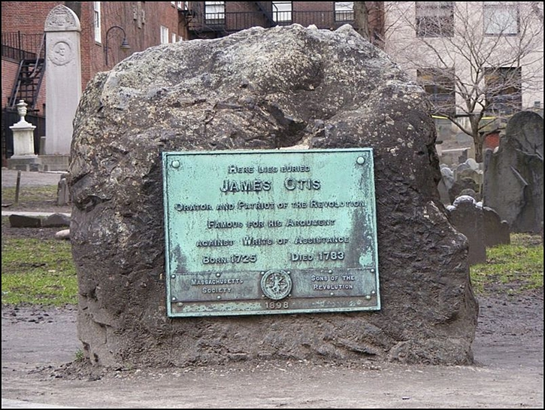
JAMES OTIS (1725-1783)
A Harvard-educated lawyer, Otis was born in Barnstable, Massachusetts. He served as Advocate General of the British admiralty court in Boston until 1760 when he resigned his position to argue against the British Writs of Assistance, an open-ended search warrant that allowed British customs officials to search private property for illegal goods without the modern equivalent's constant judicial review.

In 1762, prompted by the closing of the local legislature by royal governor Francis Bernard to end contentious debate over the use of treasury funds by Bernard without the legislature’s approval, Otis produced a 53-page pamphlet, Vindication of the Conduct of the House of Representatives of the Province of Massachusetts-Bay. It quickly came to be one of the most widely read pamphlets in the thirteen colonies and highlighted the classic fundamentals of American revolutionary theory.

The normally reserved John Adams gushed with admiration:

"Look over the declaration of rights and wrongs issued by Congress in 1774. Look into the Declaration of Independence in 1776...look into Mr. Thomas Paine's "Common Sense", "Crisis", and "Rights of Man." What can you find that is not to be found in this ‘Vindication of the House of Representatives’?”

In 1765 he protested against the Stamp Act, which required taxes paid on newspapers, deeds, licenses, mortgages and even dice and playing cards. He famously argued in his popular pamphlet, The Rights Of The British Colonies, Proved And Asserted, that since the Stamp Act had been passed in the English Parliament without going through the colonial legislatures it stood for taxation without representation.
With Samuel Adams as his behind-the-scenes supporter Otis continually made his case in supporting the rights of the colonists, using pamphlets, local newspapers and town meetings as his forum.

An increasingly unstable man, a political dispute with a loyalist to the Crown led to blows at The British Coffee House, a local tavern. Otis was severely injured and never regained his previous brilliance and, from 1771, he faded from the spotlight.
Jimmy’s Tangents:
• Even before his fateful encounter at The British Coffee House, Otis would often have moments of madness such as the night he decided to break every window in the Town House (now The Old State House)
• On another occasion Otis spent three days collecting all of his personal papers and then proceeded to burn them, an action that historians of the Revolutionary War regard as a loss of immeasurable proportions
• Otis had once predicted that he would die by a strike of lightning and in May of 1783, while watching a thunderstorm on a farm in Andover, his prediction was proven true. (Life Lesson #83: Do not lean against a metal doorway during a lightning storm.)

