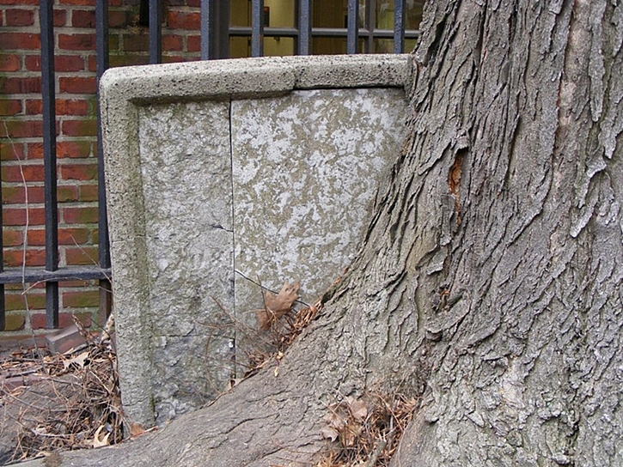
Sod Couple
Now turn around (not much choice is there?) and head straight down the long path towards the 18-ft tall Hancock memorial. About ten feet before the Hancock memorial take a gander to your right and you will see a white headstone that is locked in a permanent “tree hug” or as one guide confusingly puts it, “tree growing out of stone.” Interestingly enough the “bond” developed after the headstone had been fortified with the concrete shell.

The headstone is that of Adino Bulfinch, first generation patriarch of the accomplished Bulfinch clan. The most famous Bulfinch was Charles Bulfinch, a gentleman architect responsible for single-handedly designing Boston from 1787 to 1818 and perfecting his primary style that is now known as federalist architecture. His masterpiece, the 1798 Massachusetts State House, led to an appointment as chief architect of the US Capitol building in Washington, DC.

By the way the name Bulfinch may have sounded familiar. The bar that inspired the classic sitcom Cheers! was for years named The Bull & Finch but has since legally been changed to Cheers!

