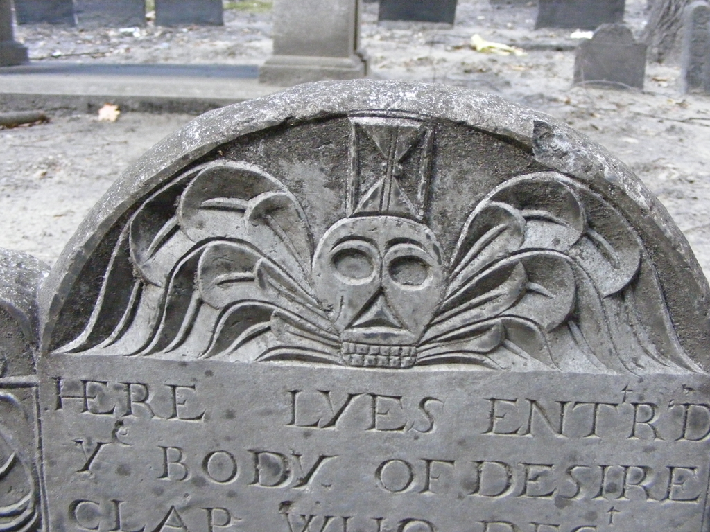
Why do so many headstones have skulls and wings?
This was at the time a reminder to the living, God-fearing Puritans of the mortality of the body (death heads, cross bones) and the immortality of the soul (wings).
Smattered among these “standard issue” headstones you will find an assortment of later editions that include cherub faces, urns, harvest scenes and willows – classical Greek and Roman motifs – that started to appear after the War of Independence.

Why are the graves placed so close to each other?

The first botanical cemetery in the country, Mount Auburn, was established in 1831 in neighboring Cambridge in order to reflect the growing view that a burial site should facilitate the positive reflection of a loved one’s life vs. the Puritan’s emphasis of stark reminders of one’s mortality. This idea of a cemetery as a public park inspired many tenders of older graveyards to “upgrade” the appearance of their domains.
Here at the Granary Burial Ground, like hundreds more in New England, this meant the removal of the original lawnmowers – cows and pigs and their generous “deposits” – and the reordering of headstones into straight lines for easier maintenance.
Needless to say the bodies were not “shuffled” along with the headstones. This prompted Oliver Wendell Holmes Sr. to quip: “Epitaphs were never known for truth but the old reproach of ‘Here lies’ never had such a wholesale illustration…”

