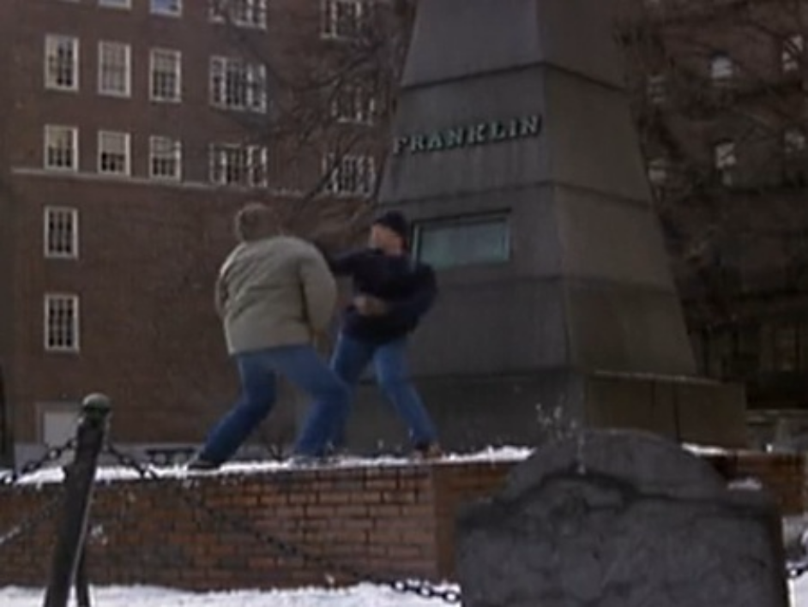 Spenser’s First Stand
This photo is a screen capture from the pilot episode of the 1985-88 detective series “Spenser: For Hire” starring Robert Urich. In this shot you can see Spenser “taking out the trash” so-to-speak on a cold winter day after a brief foot chase starting at nearby Park Street Station and ending here at the Ben Franklin Family Memorial in the Granary Burial Ground.
The bad guy had hidden behind the Franklin Memorial but to no avail since Spenser could clearly see his exhaled breath from behind the monument. After firing off a few warning ricochet shots prompting the bad guy to give up, Spenser makes his approach while verbally reminding the bad guy just where he is: “You picked the right graveyard punk. John Hancock is buried here; Samuel Adams; (lower, menacing) Paul Revere!” The two then get in a tussle that is broken up by the arrival of the police.

