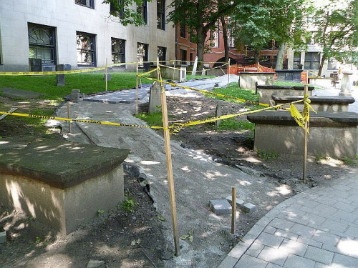
Table For Few
Continuing the theme of tomb renovations, as you make your way towards Peter Faneuil’s memorial take a gander at the table tombs lining both sides. Don’t worry, nobody is buried above ground – the “table” was simply an elegant way to mark the tomb below.
Many of these, more than in any other part of the burial ground, have been repaired in one way or another. The most inventive repair (first tomb to the left of Paul Revere - sorry if that makes you backtrack) used portions of a broken headstone to create a “mortal collage” if you will. This is one of my favorite spots in the graveyard.
This photo was taken in 2011 during the $300,000 city & state-funded improvement program that included pruning trees, increasing the size of observation areas and realigning, widening and adding new footpaths.
The Granary looks exponentially better than it did before.

