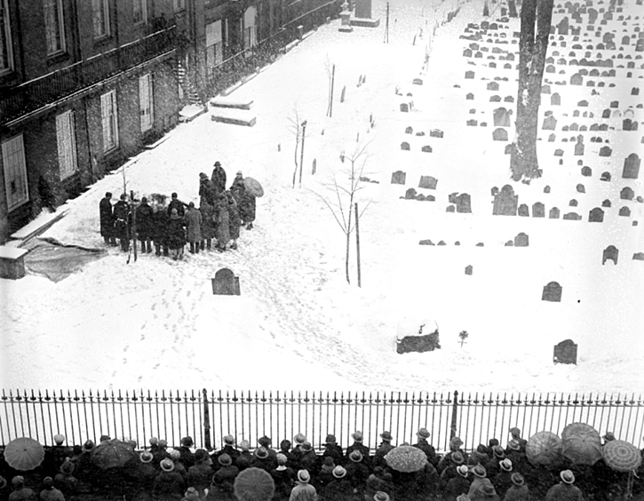
Ushered Out
Shortly before you reach the large boulder marking the grave of James Otis, look to your right where you will see a single tree matched by a single headstone and you will be approximately at the spot of our next item of interest.
Once again the Boston Public Library provides an amazing photo and at the same time answers a question I am always asked: when was the last burial.

Since the closing of the burial ground in 1879, technically the last burial here at the Granary was that of John Kettle (Tomb 76) in 1961. His burial came with one caveat – his remains were cremated. In a few minutes I’ll tell you about the mysterious case of another (reputed) late arrival in the form of Madeline Conner.

The image above is the photographic evidence of the last full-body burial here at the Granary when the mortal remains of Mrs. Isabelle Perry were placed into Tomb 31 on March 4, 1931 (note the crowd on Tremont Street.)
The Boston Globe gave some of the specifics: Perry was the head usher for the Old Howard Theater; her burial was the first in 20 years in the Granary and only the second in 75; she lived on nearby Ridgeway Lane; the tomb was prepared for her internment by the official gravedigger of the Granary, Michael Norris (infrequent as the occasion may be.)
The Globe also fleetingly mentions the possible reason why Mrs. Perry was allowed to be buried here at the Granary - Revolutionary-era lineage. Since thousands of Bostonians had similar ancestral resumes at the time, what is curiously missing in the brief Globe article is the answer to how a humble woman such as Mrs. Perry “won the lottery” in gaining an exception to the rule (no new burials) while those with “better connections” were excluded.
Trust me when I say that thousands of Bostonians would demand burials with their ancestral brethren if they could - not to mention the eternal bragging rights of “residing” in the same grounds as Revolutionary luminaries such as Paul Revere, James Otis, Sam Adams and John Hancock.

