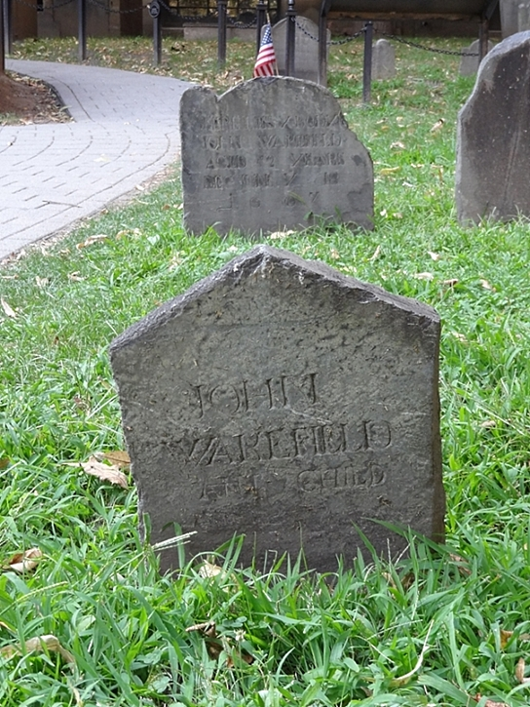
Wakefield’s Child
Now head back to the main path and take a right. A few yards up the path, in the last row on the right and closest to the path, look for the headstone of John Wakefield.
While the Neal children monument has a date of 1666 that stone was actually carved in 1672. Thus John Wakefield’s headstone is officially the oldest extant one in the Granary with a date of 1667.

But in addition to winning the unintended prize of oldest headstone, John Wakefield’s slate marker also stands out as an example of headstone recycling.
If you look on the back you will see the inscription for Ann Child, apparently the mother of a daughter that married into the Wakefield family. The first time I saw Ann’s name I knew the combination sounded familiar. Turns out that Ben Franklin’s father, Josiah, originally married a woman named Ann Child.

