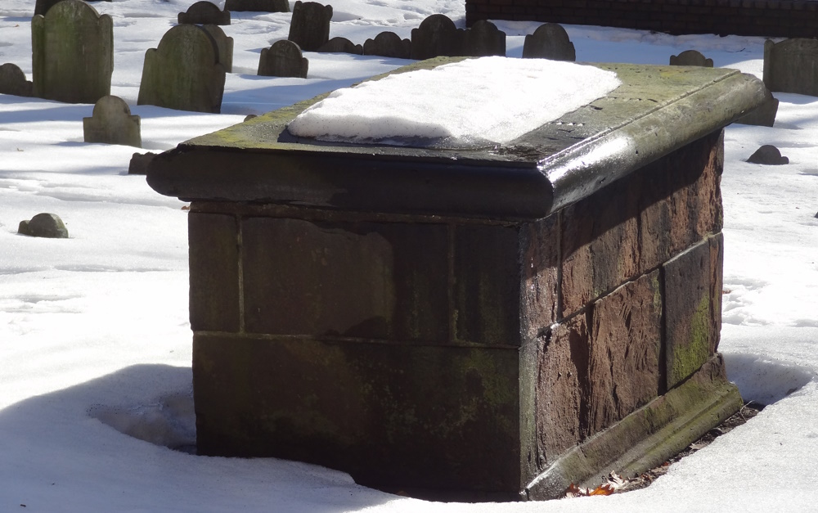
SAMUEL SEWALL (1652-1730)
Although Sewall is noted in American literature for his classic diary, chockfull of facts and ponderings reflecting the Puritan life and ethic, it was his role as a judge at the 1692 Salem Witch Trials that secured his place in American history. During this dark episode of witchcraft hysteria, thirty persons, mostly women, were condemned to death and nineteen were hanged for supposedly practicing the occult arts.
In front of the Old South Church congregation in 1696, Judge Sewall became the only judge involved in the witch trials to publicly recant his actions.

Jimmy’s Tangents:

• In his 1710 essay, The Selling of Joseph, Sewall comes out strongly against slavery thus making him one of the earliest white colonial abolitionists
• John Hull, Sewall's father-in-law, is also buried in this tomb
• Hull was the colony's, and the New World's, first coin minter when he was authorized to create what became known as the Pine Tree Shillings starting in 1652
• When Hull was appointed mint master he was paid a shilling for every twenty single shilling coins he made; authorities tried to renegotiate this lucrative arrangement but Hull refused and indeed became very wealthy
• Legend has it that when Sewall married Hull's daughter, Hannah, he was given a wedding present of Hannah’s weight in Pine Tree Shillings (luckily for Sewall, Hannah was what we refer today as a “plus” size!)
• The Pine Tree Shillings is a chapter in Nathaniel Hawthorne's collection of short stories, The Grandfather Chair

