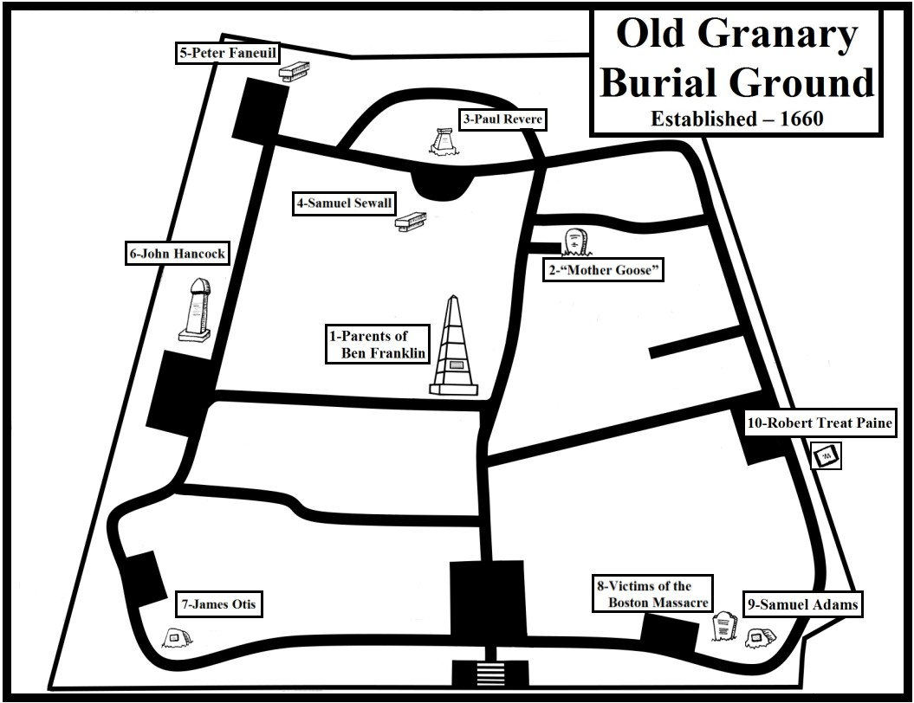
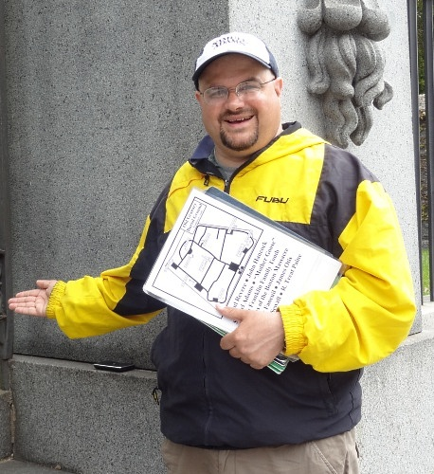
Howdy! My name is Jimmy Cole and here’s the scoop:

You are free to borrow this little guide that I put
together; just return it to me on your way out.
Donations are accepted (but not expected.)

Donations go towards my general living costs &
printing/commuting/munching expenses as well as development of my website, jimmystangents.com.
Bonus: I am aware that I jam-packed my guide with historical information. Good news! You can download a free pdf version of my guide from my website (jimmystangents.com/granary.htm) for later reading. Bonus: Colorlific!

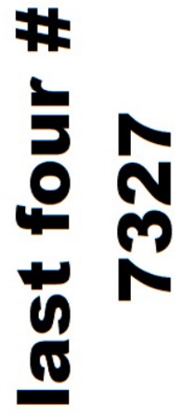 |  | 
Jimmys-Tangents | $JimmysTangents | JamesCole603

Copyright © 2007-23 by James W. Cole (“If the pages are wrinkly, it’s ‘cause it got sprinkly!”)

“Around the Granary in 80 Seconds”

Franklin Family • Boston-born Ben Franklin’s family tomb: inscription by Ben, monument by Soloman Willard

Mother Goose • Elizabeth Goose, possible author of famous nursery rhymes
Paul Revere • Famous midnight rider; silversmith, dentist, manufacturer; father and first wife Sarah also here

Samuel Sewall • Diarist; minor role as judge at Salem witch trials; repented in front of Old South congregation

Peter Faneuil • Merchant; funded construction of Faneuil Hall; given inheritance after agreeing not to marry

John Hancock • President Continental Congress; first signer of Declaration of Independence; first Governor

James Otis • argued against Writs of Assistance; Coined phrase “Taxation without representation is tyranny”

Victims of the Boston Massacre • Civilian casualties in showdown with Royal Troops

Samuel Adams • “Father of the Revolution”; signer, Declaration of Independence; 4th Governor; beer brewer

Robert Treat Paine • Signer of the Declaration of Independence; first Attorney General; MA Supreme Court

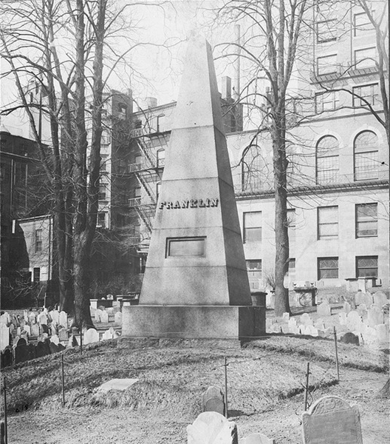JOSIAH AND ABIAH FRANKLIN

Parents of the world-famous Benjamin Franklin, Josiah and Abiah Franklin's family tomb is marked by this 21-foot stone obelisk which was donated by a group of citizens in 1827 when the original marker fell into deep decay. Both Josiah and Abiah ran a soap-and-candle business and it was in the home above the shop that Ben and his twelve other brothers and sisters grew up. Ben only lived in Boston until he was sixteen, moving to Philadelphia after he quit his job as his brother James' printing apprentice, citing both verbal and physical abuse. Ben went on to spend the majority of his very productive adult life in the "City of Brotherly Love" and is buried there. The loving inscription on the monument, the text of which follows, is from the pen of none other than Ben Franklin himself:

JOSIAH FRANKLIN AND ABIAH HIS WIFE
LIE HERE INTERRED

THEY LIVED LOVINGLY TOGETHER IN WEDLOCK FIFTY-FIVE YEARS. AND WITHOUT AN ESTATE

OR ANY GAINFUL EMPLOYMENT, BY CONSTANT LABOR AND HONEST INDUSTRY, MAINTAINED A LARGE

FAMILY COMFORTABLY, AND BROUGHT UP THIRTEEN CHILDREN AND SEVEN GRANDCHILDREN, RES-

PECTABLY. FROM THIS INSTANCE READER, BE ENCOURAGED TO DILIGENCE IN THY CALLING, AND DIS-

TRUST NOT PROVIDENCE. HE WAS A PIOUS AND PRUDENT MAN; SHE A DISCREET AND VIRTUOUS WOMAN.
THEIR YOUNGEST SON,
IN FILIAL REGARD TO THEIR MEMORY PLACES THIS STONE
J.F. BORN 1655, ___ DIED 1744, AE. 89.
A.F. ______1667, _______1752 ___85 .
________________

THE ORIGINAL INSCRIPTION HAVING BEEN NEARLY OBLITERATED
A NUMBER OF CITIZENS
ERECTED THIS MONUMENT AS A MARK OF RESPECT
FOR THE
ILLUSTRIOUS AUTHOR

Jimmy’s Tangents:

•The 1827 Franklin Monument was designed by Solomon Willard of Bunker Hill Monument fame; he also
designed the Egyptian-revival entrance in 1840
•Ben was born on Milk Street across from the Old South Meeting House (look for an embedded bust of Ben)
•Mark Twain mentioned how on one visit he had the chance to see two places where Ben Franklin was born
adding he would have seen more but he was only in town for the afternoon
•Ben's statue stands on the original site of America's first public school, Boston Latin
•He is the school's most famous dropout
•Ben's brother James established the first truly independent newspaper, The New England Courant
•Ben's statue was the first portrait statue in Boston and can be seen standing in front of Old City Hall
•Sculptor William Greenough revealed that he purposely made the 1855 statue so that the right side of Ben’s
mouth reflects the serious Ben of diplomacy, science and political theory and the left side the satirical Ben
of Mrs. Silence Dogood and Poor Richard's Almanac

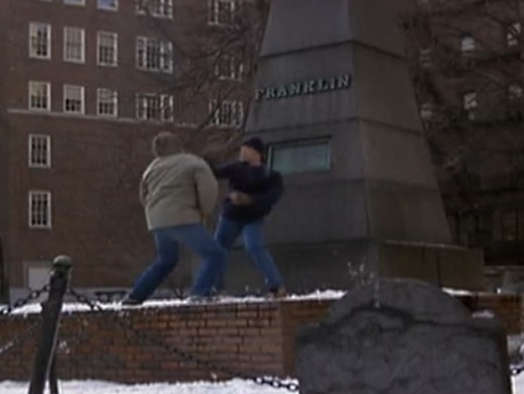Spenser’s First Stand: This photo is a screen capture from the pilot episode of the 1985-88 detective series “Spenser: For Hire” starring Robert Urich. In this shot you can see Spenser “taking out the trash” so-to-speak on a cold winter day after a brief foot chase starting at nearby Park Street Station and ending here at the Ben Franklin Family Memorial in the Granary Burial Ground. The bad guy had hidden behind the Franklin Memorial but to no avail since Spenser could clearly see his exhaled breath from behind the monument. After firing off a few warning ricochet shots prompting the bad guy to give up, Spenser makes his approach while verbally reminding the bad guy just where he is: “You picked the right graveyard punk. John Hancock is buried here; Samuel Adams; (lower, menacing) Paul Revere!” The two then get in a tussle that is broken up by the arrival of the police. Scan the code to see the scene!

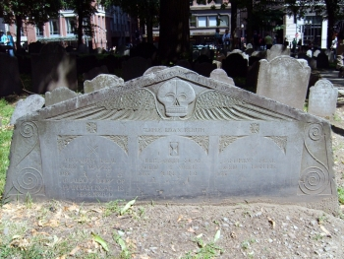

Neal & Pray: As you make your way towards Mother Goose you may want to check out one of my favorite headstones located on the right-hand side of the path, the wide, pentagon-shaped slate slab dedicated to the young deaths of the children of Andrew and Melicent Neal. The 1666 date is the oldest to be seen on any stone here in the Granary (you’ll see the actual oldest headstone shortly) and notes the age of deaths ranging from the first Elizabeth’s of three days to the passing of Andrew at eighteen months.

This grave is one of my favorites because of all the details done by the anonymous carver: the classic winged, death head; the curly-cue reliefs that look very much like a modern Clef musical notation; the Latin inscription, TEMPUS EDAX RERUM (“Time, devourer of all things”) But what I love the most is the three small symbols etched into the stone above the inscribed names: the crossbones, the hourglass and, my favorite, the two little criss-crossed shovels.

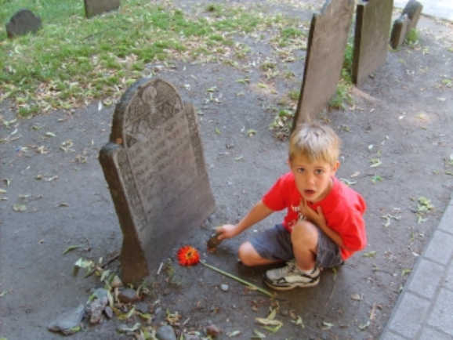BOSTON'S MOTHER GOOSE

Elizabeth Goose, who died in 1757, was the second wife of Isaac Goose. She raised 20 children - ten by Isaac's first wife Mary - and ten of her own. Legend has it that her son-in-law, Thomas Fleet, a book dealer and printer, published a book of stories titled, Songs for the Nursery or Mother Goose's Melodies. Since no copies have ever been found the legend remains unproved. The fact that the pen name "Mother Goose" was in use in England before Elizabeth's birth also casts doubt on any claims that she was indeed Mother Goose.

Unfortunately, Elizabeth's gravestone disappeared long ago. But you can still see a marker for Isaac's first wife, Mary.
Jimmy’s Tangents:

•Robert McCloskey's 1941 award-winning children's book, Make Way For Ducklings, is based in Boston
•Artist Nancy Schon created a collection of nine statues representing Mrs. Mallard and her eight ducklings:
Jack, Kack, Lack, Mack, Nack, Ouack, Pack, and Quack
•The statues can be found in the Public Garden and are easy to find - just look for kids of all ages engaged in
joyous, rollicking play as they ride the loveable little ducklings

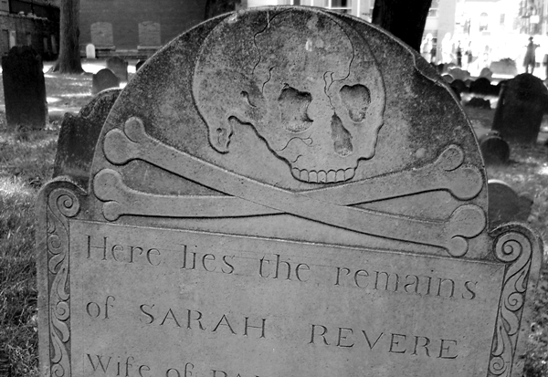Why do so many headstones have skulls and wings?

This was at the time a reminder to the living, God-fearing Puritans of the mortality of the body (death heads, cross bones) and the immortality of the soul (wings). Smattered among these “standard issue” headstones you will find an assortment of later editions that include cherub faces, urns, harvest scenes and willows – classical Greek and Roman motifs – that started to appear after the War of Independence.

Why are the graves placed so close to each other?

The first botanical cemetery in the country, Mount Auburn, was established in 1831 in neighboring Cambridge in order to reflect the growing view that a burial site should facilitate the positive reflection of a loved one’s life vs. the Puritan’s emphasis of stark reminders of one’s mortality. This idea of a cemetery as a public park inspired many tenders of older graveyards to “upgrade” the appearance of their domains. Here at the Granary Burial Ground, like hundreds more in New England, this meant the removal of the original lawnmowers – cows and pigs and their generous “deposits” – and the reordering of headstones into straight lines for easier maintenance. Needless to say the bodies were not “shuffled” along with the headstones. This prompted Oliver Wendell Holmes Sr. to quip: “Epitaphs were never known for truth but the old reproach of ‘Here lies’ never had such a wholesale illustration…”

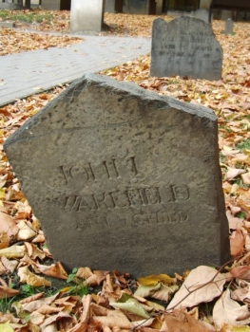Wakefield’s Child: Now head back to the main path and take a right. A few yards up the path, in the last row on the right and closest to the path, look for the headstone of John Wakefield. While the Neal children monument has a date of 1666 that stone was actually carved in 1672. Thus John Wakefield’s headstone is officially the oldest extant one in the Granary with a date of 1667.

But in addition to winning the unintended prize of oldest headstone, John Wakefield’s slate marker also stands out as an example of headstone recycling. If you look on the back you will see the inscription for Ann Child, apparently the mother of a daughter that married into the Wakefield family. The first time I saw Ann’s name I knew the combination sounded familiar. Turns out that Ben Franklin’s father, Josiah, originally married a woman named Ann Child.

Photo: The John Wakefield footstone (foreground) and headstone. Both stones feature the later addition of Ann Child's name.

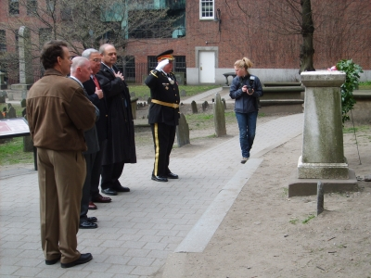

PAUL REVERE (1734-1818)

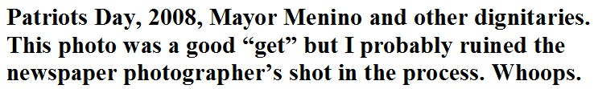A revolutionary patriot and noted American silversmith, Revere was born in Boston, the son of French Huguenots. Revere became a celebrated silversmith, considered by many to having been the best of his time. Paul was also a goldsmith, made copper engravings, surgical instruments, dental plates and political cartoons for the patriot cause. Revere's knowledge of the feelings of the average working man and his ties with them were instrumental in developing grass roots support for the Revolution. In 1770 he created the famous engraving of the "Boston Massacre," became a leader of the Sons of Liberty and helped organize the Boston Tea Party. After only getting a couple hours of sleep, Revere carried news of the Boston Tea Party to New York City and Philadelphia and by the opening shots of the Revolutionary War he was a respected figure throughout the colonies having logged thousands of miles to inform of Boston's latest political move.

Revere is most famous for his ride from Boston to Lexington to warn John Hancock and Samuel Adams that the British troops intended to arrest them and seize military supplies that had been stored by local minuteman in Concord. Along the way he alerted the Middlesex County minuteman of the impending arrival of the British troops. Poet Henry Wadsworth Longfellow immortalized the event in his 1861 poem, The Midnight Ride of Paul Revere.

During the latter part of the war Revere served as an officer and engraved the first Continental money and the official Massachusetts seal.

After the war Revere set up a foundry and manufactured gunpowder, copper balls, cannons, stoves, and numerous church bells many of which are still rung today in steeples throughout New England. Revere invented a method to roll copper and, using the process, sheathed the dome of the new State House on Beacon Hill and the bottom of Old Ironsides, the U.S.S. Constitution.

Jimmy’s Tangents:

•Henry Wadsworth Longfellow was inspired to write his poem, The Midnight Ride of Paul Revere, while visiting
Old North Church on the 85th anniversary of the event (1860)
•First published in the January 1861 edition of The Atlantic Monthly magazine it was an effort to inspire
Americans to the Union Cause by highlighting the fact that one person can make a difference
•Poem Inaccuracy #1: the signals were not to Revere but from Revere to fellow Patriots on the Charlestown side
of the bay in case Revere was captured crossing
•Poem Inaccuracy #2: Revere surely did not say, "The British are coming! The British are coming!" because
Revere and all others were still British subjects at the time
•He more likely said: "The Regulars are coming!" or “The Lobsterbacks are coming!”
•Poem inaccuracy #3: Although Revere and fellow rider William "Billy" Dawes (Dawes took the longer land
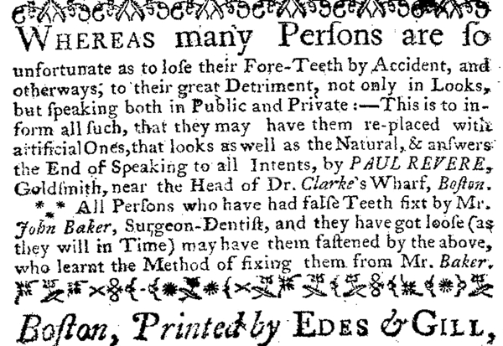 route) did reach Lexington to warn Sam Adams and John Hancock that the Regulars were on their way, neither rider completed the ride to Concord but were captured (Revere) or escaped (Dawes) British patrols
•A Dr. Samuel Prescott, whom Revere and Dawes
ran into on their way to Concord, was returning
from a late courting call and as a trusted local
member of the Sons of Liberty readily agreed to
join in their mission, escaped a patrol of Royal
Troops that captured Revere and Dawes, and
completed the most famous horse ride in history
•After the use of Old North Church's steeple to
display the infamous lantern signals, the Old
West Church had its steeple torn down so as to
not be used for similar signaling across the bay to
Cambridge and Charlestown
•Revere’s side occupation of dentistry led him to being involved in what has been deemed one of the earliest
examples of forensics techniques used to identify a buried, decomposed body. General Joseph Warren had died
at the Battle of Bunker Hill and was buried in a mass grave along with numerous colonial soldiers that had also
fallen in the battle. Revere noted prior to the search and eventual excavation of Warren’s body the details of
a dental plate that he had made for Warren. When the body believed to be Warren’s was located and exhumed,
the dental plate Revere had described was indeed found to match Revere’s description (with Revere himself
making a visual identification.) Warren was subsequently briefly buried in a tomb here at the Granary, then
moved to a crypt down Tremont Street at St. Paul’s church and eventually moved one more time to his final
resting place in Forest Hills Cemetery, a few miles away.
•Biographer Esther Forbes noted that near the end of his life if Revere wanted to see many of his old friends, he
would come down here to the Old Granary Burying Ground
•The largest bell Revere ever cast at his foundry was the 2,437 lb. model still used at King's Chapel, a stone’s
throw away; upon Revere's death in May of 1818, the bell was slowly rung in his honor 83 times, one ring for
every year of Paul’s longest and most productive ride of all – life.
•On January 17, 1950, hours before the men who would commit the largest cash robbery up to that time in
American history, The Great Brinks Robbery, lead thief Tony Pino called each of his ten other cohorts with the
coded message "Paul Revere is off!" to signal that the robbery was to go ahead that night
•One of the most successful groups of the sixties, Paul Revere and the Raiders, was indeed led by a man named
in honor of the Midnight Rider and was started in…where else…Boise, Idaho (Gotcha!)

Paul’s In Stead?
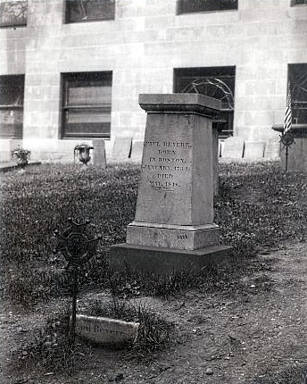While browsing through the Flickr photo archives of the Boston Public Library (BPL) I came upon this amazing photo, which managed to confirm a nagging suspicion I have had on my mind for over twenty years. I would guesstimate the photo to having been made on or shortly after 1897 since the higher resolution photo clearly shows the unfinished outer walls of the Congregational House (completed 1898.)

In the photo you can see the larger 1885 public subscription monument and in front of it a smaller, straight-edged object protruding from the ground roughly where you see the granite curb installed today. The smaller object reads: “Paul Revere’s Tomb” and after a quick comparison (size, shape, type of stone, etc.) it became apparent to me that it was not the same small, rounded tombstone you see embedded a few feet to the right today Thus it is unfortunately clear now, due to this photo, that the small tombstone seen today is a replacement. Of the limited info I could recently dig up, it appears that the placement of the current headstone probably occurred in the early 1970’s when the semi-circular standing area was created.

After tossing all of this physical evidence around in my noggin for a little while, it finally hit me what had been the cause of the nagging suspicion I have had had all these years about the tombstone to be seen today – the simple inscription. For years I had a “Jimmy’s Tangents” listing that said Revere reputedly got his headstone as a gag gift when he was much younger but that it had indeed become his tombstone. While I only had one source for that story it made sense to me at the time because it was the only way to explain the current marker’s presumptive inscription. On the older tombstone in the photo the inscription reads “Paul Revere’s Tomb.” For whom is this tombstone? Revere. Which Revere? Paul. And yet the “Revere’s Tomb” etching on the current marker clearly presumes that the viewer will know which Revere. This fantastic photo, while creating a few new questions to be answered, at least puts to rest the notion that the current smaller marker is Paul Revere’s original tombstone.

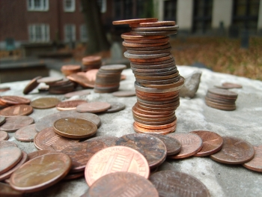So what’s the deal with stones and coins on top of some graves?

Unless you are visiting immediately after a periodical Parks Dept. cleanup, chances are you will see stones and coins placed on graves, primarily people of renown. So what’s the deal? From what I have been able to discover, leaving a stone is a Jewish tradition called Mitzvah of Matzevah (“setting of stone”) that grew out of the early funeral tradition that involved the body of the deceased being buried and each mourner placing a small stone on top to create a cairn. The cairn not only marked the grave (particularly necessary when their Jewish brethren were buried in the desert) but also protected the mortal remains from hungry animals.

Today that tradition plays out more in the form of each pebble or stone being, in essence, a calling card of respect. Paul Revere, Sam Adams, John Hancock are not Jewish so the tradition has clearly evolved into a secular one and today is more of an exercise in mimicking than being in-the-know, with kids generally at the forefront of the effort.

As to the coins: When visiting Ben Franklin’s grave at Christ Church in Philadelphia the tradition is to leave a penny, presumably due to Ben’s “A penny saved is a penny earned” advice. If any one person had a tradition created just to honor them (and then copied) it would be Ben. Another reason could be the mimicking of the ancient tradition of placing gold coins with the deceased to pay the toll charged by Charon, the boatman of the Underworld, for passage to the other side of the river Styx; reputedly to not do so was to condemn the deceased to wander the shores for eternity and thus never find peace. There is a very slim chance that some place pennies on Paul Revere’s grave to reflect his work in engraving in copper, most famously his 1770 Boston Massacre print. In the end I believe that people mostly place coins, just like the stones, as a form of good-willed mimicry.
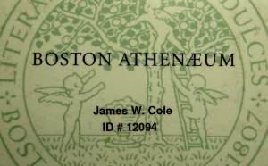Bathens: The building directly behind Paul Revere and extending to the right corner is the prestigious Boston Athenaeum. Founded in 1807, this private library is a treasure trove not just of books but also works of art from the likes of Chester Harding, Gilbert Stuart, Daniel Chester French and many others. Former members include Ralph Waldo Emerson, Daniel Webster, Oliver Wendell Holmes Sr., Henry David Thoreau, John Kennedy and James Cole. (OK, I am James Cole and thus admit that placing my name in the anchor position of former members was a shameless way to associate myself with those world-renown personas but, until I fork out the cash to join again, the fact remains…I am a former member.)

Current members David McCullough ("John Adams" "Truman") Doris Kearns Goodwin ("The Fitzgeralds and the Kennedys") and Ken Burns ("Civil War" mini-series) did a large amount of their research within this historical edifice. A majority of George Washington's personal library reside here while, on the other end of the spectrum, a book with a cover made of human skin (yikes!) from a convicted murderer also makes it's home here.

Speaking of George Washington, for decades the Athenaeum was the home of the famous unfinished 1796 Gilbert Stuart painting of the first President. You know the painting. In fact chances are you are carrying a copy right now since the Stuart portrait is to be found printed on every US dollar bill. The Athenaeum acquired the painting (along with the similarly unfinished Martha Washington companion) for $1,500 three years after Stuart’s 1828 death. In 1980 the paintings were sold for $2,500,000 under a unique joint-ownership agreement between the Museum Of Fine Arts here in Boston and the Smithsonian Institution in Washington, DC, with the paintings residing three years in one institution, then three years in the other, in perpetuity.

Directly across from the Revere Memorial and just behind the large information marker you will see two table tombs.

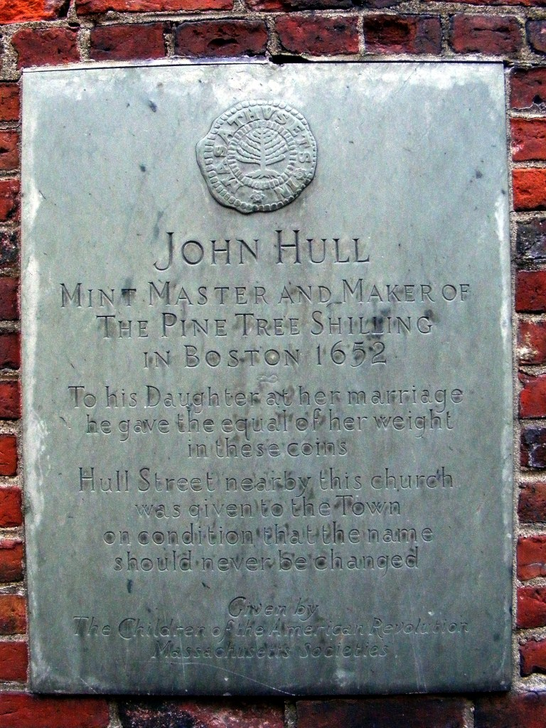SAMUEL SEWALL (1652-1730)

Although Sewall is noted in American literature for his classic diary, chockfull of facts and ponderings reflecting the Puritan life and ethic, it was his role as a judge at the 1692 Salem Witch Trials that secured his place in American history. During this dark episode of witchcraft hysteria, thirty persons, mostly women, were condemned to death and nineteen were hanged for supposedly practicing the occult arts. In front of the Old South Church congregation in 1696, Judge Sewall became the only judge involved in the witch trials to publicly recant his actions.

Jimmy’s Tangents:

•In his 1710 essay, The Selling of Joseph, Sewall comes out
strongly against slavery thus making him one of the earliest
white colonial abolitionists
•John Hull, Sewall's father-in-law, is also buried in this tomb
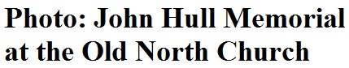•Hull was the colony's, and the New World's, first coin
minter when he was authorized to create what became
known as the Pine Tree Shillings starting in 1652
•When Hull was given the position of mint master he was
paid a shilling for every twenty single shilling coins he made;
authorities tried to renegotiate this lucrative arrangement
but Hull refused and indeed became very wealthy
•Legend has it that when Sewall married Hull's daughter, Hannah, he was given a wedding present of Hannah’s
weight in Pine Tree Shillings (luckily for Sewall, Hannah was what we refer today as a “plus” size!)
•The Pine Tree Shillings is a chapter in Nathaniel Hawthorne's collection of short stories, The Grandfather Chair

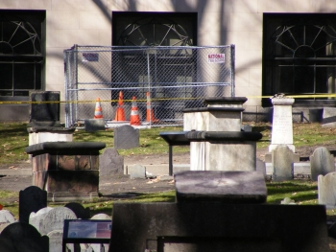Hole Down Dance: Due to popular inquiry - In late January of 2009 a woman was poking around some graves a few yards behind Paul Revere’s tomb when she “discovered” – up to her hips – a long-covered entry to what is now believed to be the tomb of Jonathan Armitage, a former town selectman in the early 1700’s (Boston was granted a city charter in 1822). Apparently in wandering off the beaten path she had stepped directly onto a large slab of slate placed flush in the ground to cover the tomb’s entry when the slab gave way, courteously breaking in two. The woman was not injured but the burial ground was briefly closed due to repairs. The old, broken slab of stone has since been replaced with a new, unbroken one and is scheduled to break, due to a wandering tourist, in the year 2287 (“Dear Parks Dept: just kidding!”) BTW, the replacement slab was covered with dirt and is now hidden again under a fresh patch of grass so there is no trace of the “Hole Down Dance” to be discovered.)

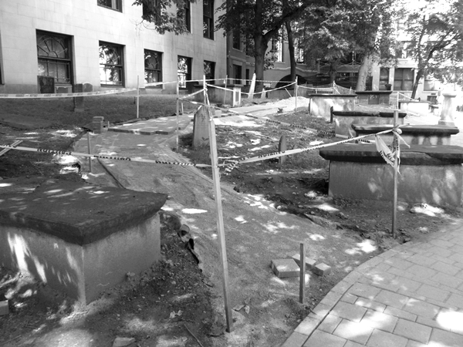Table For Few: Continuing the theme of tomb renovations, as you make your way towards Peter Faneuil’s memorial take a gander at the table tombs lining both sides. Don’t worry, nobody is buried above ground – the “table” was simply an elegant way to mark the tomb below. Many of these, more than in any other part of the burial ground, have been repaired in one way or another. The most inventive repair (first tomb to the left of Paul Revere - sorry if that makes you backtrack) used portions of a broken headstone to create a “mortal collage” if you will. This is one of my favorite spots in the graveyard. This photo was taken in 2011 during the $300,000 city & state-funded improvement program that included pruning trees, increasing the size of observation areas and realigning, widening and adding new footpaths. The Granary looks exponentially better than it did before.

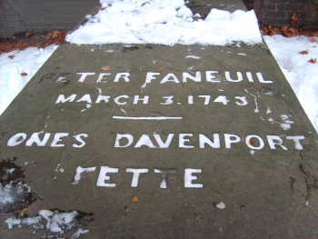Peter Faneuil (1700-1743)

Peter Faneuil's father died when he was 18 and his wealthy uncle, one Andrew Faneuil, a prominent merchant whose ships called at ports around the Atlantic, adopted Peter. When Andrew died Peter inherited his uncle's fortune but only after agreeing to one provision: like Andrew he had to remain a bachelor. Peter honored his uncle's wishes naming one of his ships the "Jolly Bachelor" and indeed he was, entertaining with lavish dinners nightly at his stately home.

In 1742 he donated the funds for the construction of Faneuil Hall. But only a few months after the completion of this venerable building Faneuil would live up to his ship's name, dying of "too much good living."

Jimmy’s Tangents:

•The vote to accept Peter's offer to fund his central market passed with a vote of 367-360 but only after Peter
offers to also build a second floor to house a town meeting hall
•This arrangement of town hall above and food market below inspired Francis Hatch to write in 1958: "Here
orators in ages past / Have mounted their attacks / Undaunted by proximity / Of sausage on the racks."
•Shortly after it's 1742 debut the first major event to take place in the hall ironically was the public memorial
for the deceased Peter
•Brother Benjamin, first in line for Uncle Andrew's fortune but forfeited when he got married, inherited Peter's
fortune, proving that sometimes you can have your cake and eat it too.
•The original 1742 grasshopper weather vane by Sheme Drowne still graces Faneuil Hall
•In 1974 the grasshopper was stolen and eventually found five days later hidden under flags in the building’s
cupola but not before 28 other previously stolen weather vanes were recovered by authorities
•The Boston police officer that cracked the case? - The patriotically-named Detective Paul Revere Carroll.

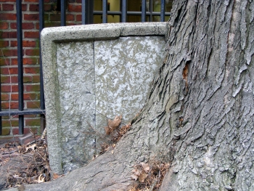Sod Couple: Now turn around (not much choice is there?) and head straight down the long path towards the 18-ft tall Hancock memorial. About ten feet before the Hancock memorial take a gander to your right and you will see a white headstone that is locked in a permanent “tree hug” or as one guide confusingly puts it, “tree growing out of stone.” Interestingly enough the “bond” developed after the headstone had been fortified with the concrete shell.

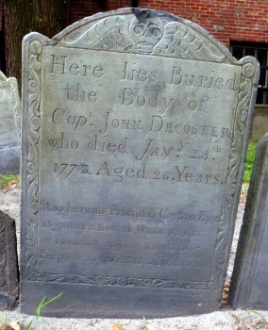The headstone is that of Adino Bulfinch, first generation patriarch of the accomplished Bulfinch clan. The most famous Bulfinch was Charles Bulfinch, a gentleman architect responsible for single-handedly designing Boston from 1787 to 1818 and perfecting his primary style that is now known as federalist architecture. His masterpiece, the 1798 Massachusetts State House, led to an appointment as chief architect of the US Capitol building in Washington, DC.

By the way the name Bulfinch may have sounded familiar. The bar that inspired the classic sitcom Cheers! was for years named The Bull & Finch but has since legally been changed to Cheers!

Graveitational Pull ►: Now before we toodle over to the Hancock Memorial let me just mention the poetic headstone of Cap. John Decoster. His marker is easy enough to find. Looking straight at the “Sod Couple” from the walkway you should be standing in front of the headstone for one Waitstill Trott. Two headstones to the right you’ll find the late Cap.’s stone. Below the standard info of his name, year of death, etc. is a short poem that you may have heard some rendition of before, reputedly scribed by a 12th century English prince. Decoster’s version reads: “Stop here, my Friends, and Cast an eye / As you are now, so Once was I / As I am now, so you must be / Prepare for Death and Follow me.” It seems to me the right retort to Decoster’s grave invitation would be: “To follow you I will not consent / Until I know which way you went!”

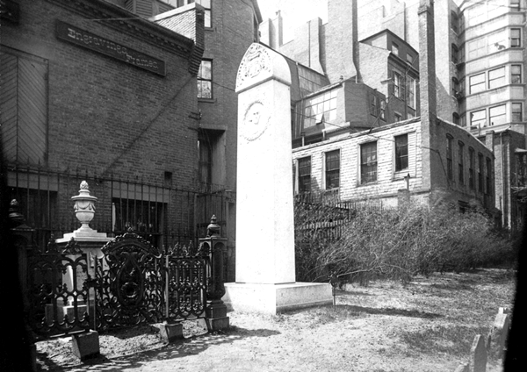JOHN HANCOCK (1737-1793)

A merchant, public official, and first signer of the Declaration of Independence, Hancock was born in Braintree, Massachusetts. When he was a child John’s father died and he was subsequently raised by his Uncle Thomas at his estate on nearby Beacon Hill and eventually graduated from Harvard. After inheriting his uncle’s mercantile firm in 1764 Hancock became the richest Bostonian of his time.

As a businessman Hancock was brought into the fray over the Stamp Act and other British commercial policies. Fostering a spirit of defiance he named one of his newest ships Liberty to openly challenge the trade regulations. With an estimated 1,000 citizens dependent upon his business, several riots erupted when the Liberty was seized by customs officials for being used in the act of smuggling.

Soon thereafter, with the support of Samuel Adams, Hancock was elected to a seat in the Massachusetts House legislature. He was a delegate to both Continental Congresses and, as President of the second, was the first to boldly sign the Declaration of Independence, large enough so that King George III could recognize Hancock’s signature without the use of his reading glasses.

After the war he helped draft the Massachusetts constitution and was elected the state’s first governor. His political instincts led him to abruptly resign as Governor in 1785, leaving newly minted Governor James Bowdoin to deal with the brief but potent “Shay’s Rebellion.” In 1787 he returned to the Governorship and died on October 6, 1793 at the age of 56 while serving his ninth yearly term as governor.

Jimmy’s Tangents:
•On a grand tour of all thirteen colonies shortly after being elected to his first Presidential term, George
Washington nearly refused to enter town when Hancock, the reigning governor, was not among the welcoming
party. Hancock felt that as the chief executive of the state Washington should greet him. It took all the
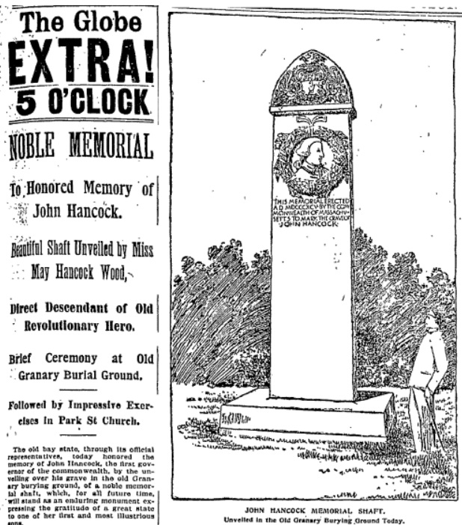 persuasive powers of Sam Adams and
then-Vice President John Adams to get
Washington to continue along.
•Hancock quickly realized his mistake, paid
a visit to Washington’s lodgings the next
day wrapped with an extensive collection
of bandages and claiming a horrible case
of the gout. Washington, upon seeing
his old Revolutionary cohort in such a
state, and reportedly with a tear in his eye,
accepted Hancock’s invitation for tea the
next day at Hancock’s Beacon Hill
mansion where all was forgiven.
•Hancock displayed an effective advocacy
for the rights of African-Americans: he
attested to the Royal Governor on behalf
of Phillis Wheatley’s authorship of her
Poems On Various Subjects, Both Religious And Moral (as did Sam Adams) in 1773;
he supported the formation of an all-black
military company, The Bucks of America,
in 1775; and he supported the ratification
of the 1781 Mass. Constitution and it’s
implied outlawing of slavery (legally
settled in 1783)
•Up until 1895 the only evidence of
Hancock’s burial here at the Granary was
a slate slab placed flush in the ground that
simply read "Hancock - Tomb 16”
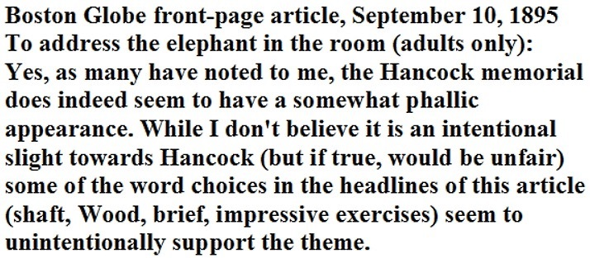•The Massachusetts Legislature resolution
that led to the creation of the current 18-
foot granite memorial was sponsored by a
black legislator named Robert Teamoh
•On the Hancock coat-of-arms, the Latin
phrase, “Obsta Principiis” has several
translations: “First In Resistance”; “Resist the
First Encroachments”; or the somewhat more
contemporary, “Nip It In The Bud”
•Abiah Holbrook, the writing teacher that
taught Hancock the art of penmanship at
the South Writing School, also “resides” here at the Granary
•The New State House (only in Boston would a 1798 building be called “New”) is built on Hancock’s former land
•The former Hancock mansion lost a last chance at survival in 1863 when a state legislature motion to preserve
the house as a historical artifact lost by a single vote; the loss so outraged the local populace that efforts to
preserve the Old South Meeting House (1872) and the Old State House (1881) became overwhelming successes
•The 1947 Hancock Building in the Back Bay district houses a neon-lit weather beacon that still uses color codes
to announce future weather: “Steady blue, clear view; flashing blue, clouds are due; steady red, rain ahead;
flashing red, snow instead”
•During the Red Sox’s baseball season the flashing red indicates that the game at Fenway has been rained out
•In 1976 the brand new John Hancock Tower, at 790 feet New England’s tallest structure, had to have all 10,344
windows replaced when the lead solder holding together each double-paned sheet of glass became brittle and
didn’t allow for any natural sway during periods of strong winds (it was nicknamed “The Plywood Palace”)
•Also due to wind concerns two 300-ton steel-lined lead “dampers” had to be placed on opposite ends of the 58th
floor, each resting on lubricated steel plates. Ingeniously designed by William LeMessurierhen, the custom-
designed springs and shock absorbers, in combination with the lubricated steel plates, make the 300-ton
dampers actually remain in place while the building “surfs” underneath (only a few inches each way!)

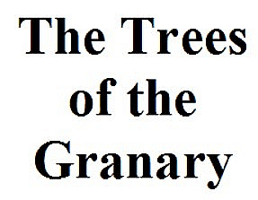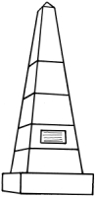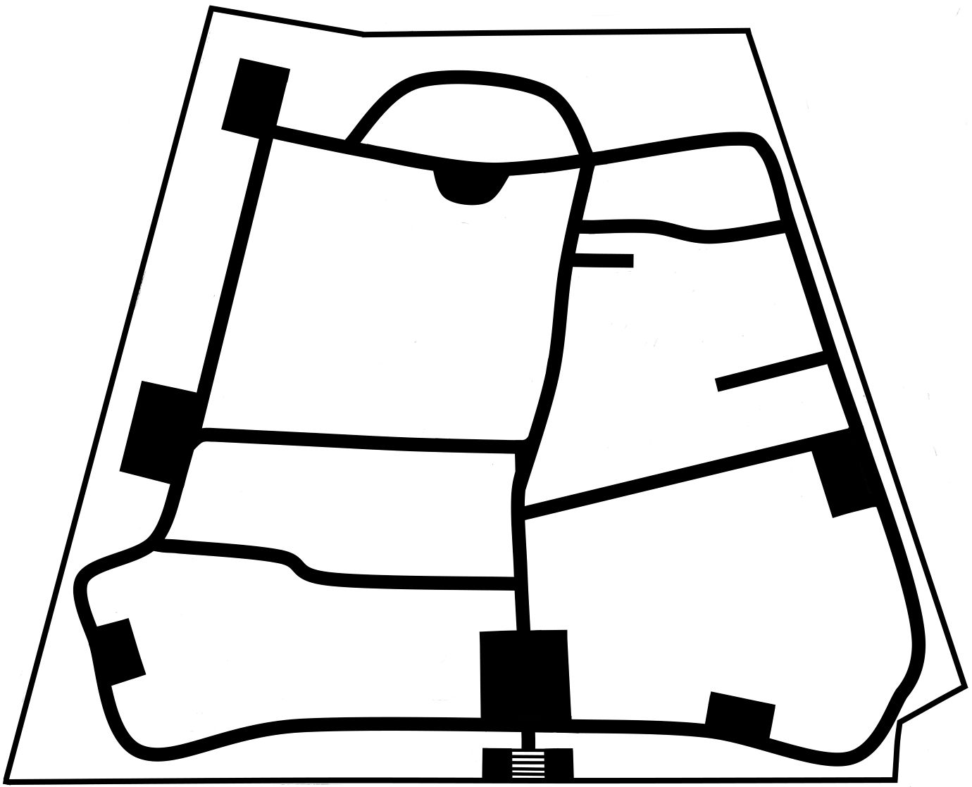

Linden Oak Magnolia Dogwood Honey Locust Horse Chestnut
Arbor Lay: If you were to divide the burial ground into four roughly equal quadrants, tree-wise the top left sector would certainly win the award for diversity with one of each - honey locust, horse chestnut, dogwood, linden and oak. Of those five, the two unquestionable stars are the honey locust, due to its unique growth around the Adino Bulfinch headstone that I wrote about a couple of pages back in The Sod Couple and the dogwood that, come springtime, after ten months of posing as a small, unassuming specimen, bursts overnight into a brilliant halo of bright white leaves that would make albino-haired musician Johnny Winter feel right at home. (BTW – note the size of the linden trees in the 1931 photo on the next page. Apparently the one closest to John Hancock didn’t make it.)

Of the remaining three quadrants (or would that be “tree quadrants”) both the top-right and bottom-right are a sea of linden, with a single oak in each to break up the majority-species’ monopoly. The bottom-left quadrant again is linden-dominated but if this group of trees were a band, come springtime, the lead singers would be the pair of New England magnolia trees by the wrought iron fence. For around three weeks this duo becomes unquestionably the belle of the sidewalk ball as the resulting sea of intense white/pink petals not only overtakes the visual landscape but actually bows down the branches, thus becoming an irresistible target of adults and shoulder-riding youngsters alike.
Arbor Slay: For years a half-dead honey locust clung to life just to the right of the Franklin Family monument but was mercifully taken out of it’s misery in 2011. A year later the burial ground’s solitary ash tree was removed due to disease and a dangerous leaning disposition, the mentioning of which allows me to tangentially segue to…

The Cane Mutiny: Whenever I pass the stump of that ash tree (back right corner) I can’t help but think of the classic story of when President Calvin Coolidge, prior to the start of an official event, was to be presented with a wooden ceremonial cane. After several minutes of the opening speaker making numerous metaphorical comparisons of the President and the strength, durability and unbending nature of the hickory tree that the cane had been born from, Coolidge stood up and received the memento and was asked to make any comments as he pleased. Long know as “Silent Cal” for his short-but-sweet style, Coolidge gave the cane a good look over from a variety of angles, tapped it once, took a quick sniff, and with a puckish smile, proclaimed: “Ash.” He then politely nodded and sat back down.

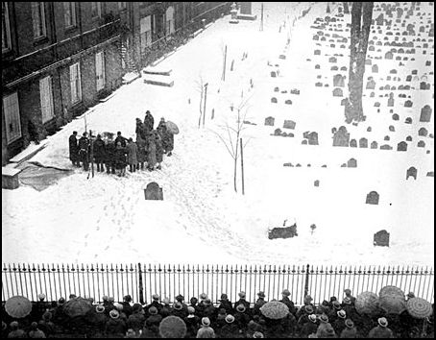Ushered Out Shortly before you reach the large boulder marking the grave of James Otis, look to your right where you will see a single tree matched by a single headstone and you will be approximately at the spot of our next item of interest. Once again the Boston Public Library provides an amazing photo and at the same time answers a question I am always asked: when was the last burial.

Since the closing of the burial ground in 1879, technically the last burial here at the Granary was that of John Kettle (Tomb 76) in 1961. His burial came with one caveat – his remains were cremated. In a few minutes I’ll tell you about the mysterious case of another (reputed) late arrival in the form of Madeline Conner.

The image above is the photographic evidence of the last full-body burial here at the Granary when the mortal remains of Mrs. Isabelle Perry were placed into Tomb 31 on March 4, 1931 (note the crowd on Tremont Street.) The Boston Globe gave some of the specifics: Perry was the head usher for the Old Howard Theater; her burial was the first in 20 years in the Granary and only the second in 75; she lived on nearby Ridgeway Lane; the tomb was prepared for her internment by the official gravedigger of the Granary, Michael Norris (infrequent as the occasion may be.) The Globe also fleetingly mentions the possible reason why Mrs. Perry was allowed to be buried here at the Granary - Revolutionary-era lineage. Since thousands of Bostonians had similar ancestral resumes at the time, what is curiously missing in the brief Globe article is the answer to how a humble woman such as Mrs. Perry “won the lottery” in gaining an exception to the rule (no new burials) while those with “better connections” were excluded. Trust me when I say that thousands of Bostonians would demand burials with their ancestral brethren if they could (not to mention the eternal bragging rights of “residing” in the same grounds as Revolutionary luminaries such as Paul Revere, James Otis, Sam Adams and John Hancock.)

Now as you reach the Tremont Street fence the path will curve in front of the boulder marking the tomb of…
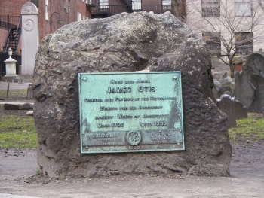
JAMES OTIS (1725-1783)

A Harvard-educated lawyer, Otis was born in Barnstable, Massachusetts. He served as Advocate General of the British admiralty court in Boston until 1760 when he resigned his position to argue against the British Writs of Assistance, an open-ended search warrant that allowed British customs officials to search private property for illegal goods without the modern equivalent's constant judicial review.

In 1762, prompted by the closing of the local legislature by royal governor Francis Bernard to end contentious debate over the use of treasury funds by Bernard without the legislature’s approval, Otis produced a 53-page pamphlet, Vindication of the Conduct of the House of Representatives of the Province of Massachusetts-Bay. It quickly came to be one of the most widely read pamphlets in the thirteen colonies and highlighted the classic fundamentals of American revolutionary theory.

The normally reserved John Adams gushed with admiration:

"Look over the declaration of rights and wrongs issued by Congress in 1774. Look into the Declaration of Independence in 1776...look into Mr. Thomas Paine's "Common Sense", "Crisis", and "Rights of Man." What can you find that is not to be found in this ‘Vindication of the House of Representatives’?”

In 1765 he protested against the Stamp Act, which required taxes paid on newspapers, deeds, licenses, mortgages and even dice and playing cards. He famously argued in his popular pamphlet, The Rights Of The British Colonies, Proved And Asserted, that since the Stamp Act had been passed in the English Parliament without going through the colonial legislatures it stood for taxation without representation. With Samuel Adams as his behind-the-scenes supporter Otis continually made his case in supporting the rights of the colonists, using pamphlets, local newspapers and town meetings as his forum.

An increasingly unstable man, a political dispute with a loyalist to the Crown led to blows at The British Coffee House, a local tavern. Otis was severely injured and never regained his previous brilliance and, from 1771, he faded from the spotlight.

Jimmy’s Tangents:
•Even before his fateful encounter at The British Coffee House, Otis would often have moments of madness
such as the night he decided to break every window in the Town House (now The Old State House)
•On another occasion Otis spent three days collecting all of his personal papers and then proceeded to burn
them, an action that historians of the Revolutionary War regard as a loss of immeasurable proportions
•Upon hearing of the Battle of Bunker Hill in progress Otis made his way to Charlestown and joined the fight
•Otis had once predicted that he would die by a strike of lightning and in May of 1783, while watching a
thunderstorm on a farm in Andover, his prediction was proven true. (Life Lesson #83: Do not lean against a
metal doorway during a lightning storm.)

THE VICTIMS OF THE BOSTON MASSACRE

On October 1, 1768, British redcoats arrived in Boston, sent by King George III to restore order after several Royal customs officials were beaten following the seizure of John Hancock's ship, Liberty, for smuggling to avoid paying the required duties. For the next 18 months the towns people and the soldiers lived in an increasingly charged atmosphere as taunts, name-calling and scuffles marked the daily life of the town. To make matters worse the local economy was in a deep recession and local unemployed workers found themselves in competition with off-duty soldiers for jobs in Boston's tight labor market.

After 12 year-old Christopher Snider was killed by a loyalist in an anti-customs riot eleven days earlier, the climax came on the cold, snowy evening of March 5, 1770. There had been several skirmishes with soldiers that day and the word on the street was that that night there would be more trouble.

Around nine p.m. an angry crowd of townspeople cornered a lone sentry outside the Custom House within the
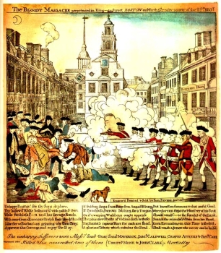shadow of the Old State House. When someone rang a nearby church bell - normally used to warn of a fire - several hundred more arrived, many armed with clubs and sticks. When the cornered sentry's cry for help brought Captain William Preston and a file of eight armed soldiers to the rescue the crowd surrounded them and prevented their return to the guardhouse. For the next fifteen minutes the crowd grew uglier, daring the soldiers to fire, cursing them, pressing closer and closer. Snowballs and rocks flew through the air. The fuse was finally lit when a thrown club hit one of the soldiers knocking him to the ground. The injured soldier stood up and fired at point-blank range. The other soldiers, confused and in fear of their lives, followed suit.

Captain Preston frantically ordered his men to cease-fire but the damage was done. Three died immediately. One died the next morning. The fifth victim would die several days later.

The slain men were a cross-section of Boston. The first to fall, Crispus Attucks, was black; another, Patrick Carr, was Irish. Samuel Gray, Samuel Maverick and James Caldwell were all apprentices to local craftsman.

Samuel Adams labeled the incident the "Bloody Massacre" and used it to force the removal of the troops to Castle Island in the harbor ending a two-year occupation. Paul Revere made a famous engraving of the episode that, although factually inaccurate, was great propaganda. Copies of it were sold throughout the town and carried all over the colonies as well as back to England. A few days later an elaborate funeral organized by Samuel Adams drew thousands of angry mourners here to the Old Granary Burying Ground.

Future president John Adams and Josiah Quincy bravely risked their patriot reputations by defending Captain Preston and the eight soldiers in the subsequent trials. They won acquittals for all but two of the soldiers. Found guilty of manslaughter the two soldiers pleaded benefit of clergy that allowed them to read or write a verse of Scripture and forego prison. To insure that benefit of clergy could only be used once the two guilty soldiers each had a thumb branded with the letter M for manslaughter.

Jimmy’s Tangents:

•The famous engraving that Revere made was a copy of one done by a younger Henry Pelham; Revere was
simply faster at getting his copy to press to the chagrin of Pelham (all eventually forgiven)
•Edward Palmer built the first town stocks in Boston on the future site of the Boston Massacre and became the
first placed in them. His offense? Overcharging for his services!
•On July 11, 1976, Queen Elizabeth made a tour of all the major revolutionary sites including the Old State
House and the site of the Boston Massacre
•The Queen mentioned that since she was the great-great-great-great granddaughter of King George III, Paul
Revere, Sam Adams and other Revolutionaries of the time might be surprised at her Royal presence. Then, with
a grin, added, "But perhaps they would have been pleased."

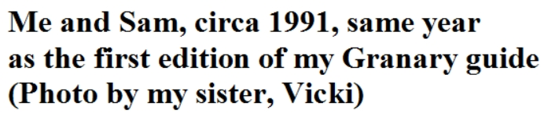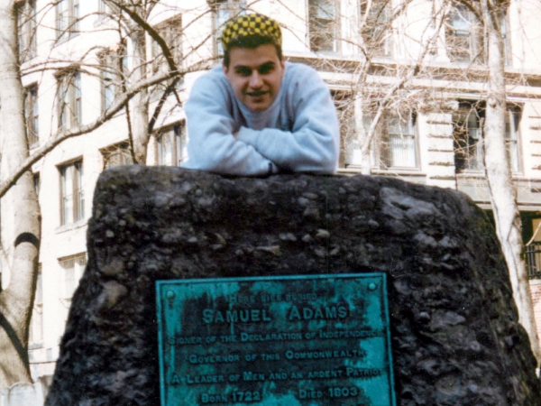Absolutely Fabiolous: Before we get to the short bio of Sam Adams, it seems appropriate to answer the real question everybody seems to have about Sam: Did he brew beer? Yes. The small brewery Sam inherited from his father failed for lack of commitment due to Sam’s real love, politics. But that was no reason for Jim Koch, founder of the Boston Beer Company (est. 1984), to not name his signature beer after the patriot. Using a recipe his great-great grandfather, Louis Koch, created in 1860, Koch went with the name Samuel Adams, feeling that just as Sam had spawned a political revolution by taking on the political powers-that-be, Koch would set out to create a revolution in beer brewing to take on what he felt was a stagnant, unimaginative beer market dominated by a handful of large brewers. Needless to say Koch’s vision was almost immediately successful, spearheading the now-robust microbrew industry and still remains the dominant microbrewery in the US. But when it came to decide on a beer label logo, apparently Sam’s personal appearance was deemed in need of improvement. The primary image of Sam considered most realistic was painted by John Singleton Copley and while I would agree with others that have asserted that Sam would not win any “hunk” contest, I will, however, dispute those tour guides, both oral and written, that label Sam as “real ugly” “hideous” etc. The label’s logo image does, as some contend, look very much like Paul Revere, again through the paintbrush of John Singleton Copley. But in my opinion the persona the Boston Beer Co.’s Sam Adams logo looks most like is Fabio of romance novel cover art fame! So if you order a Sam Adams beer make sure to get a bottle (the original Boston Lager is my favorite) and see if you agree that the label’s image is indeed Absolutely Fabiolous!

Sam | Paul
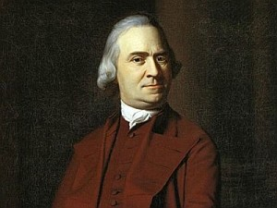 | 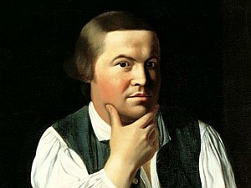
George | Ringo
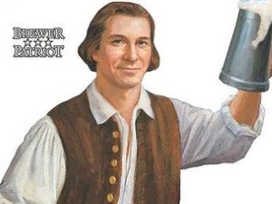 | 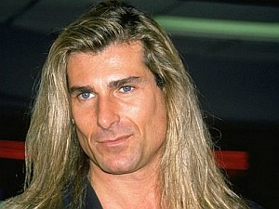
* Not Pictured: Billy (Beatles fans will get it)
SAMUEL ADAMS (1722-1803)

"What do we mean by the Revolution? The war? That was no part of the Revolution. It was only an effect and a consequence of it. The Revolution was in the minds of the people, and this was effected, from 1760 to 1775, in the course of fifteen years before a drop of blood was drawn at Lexington."
- John Adams to Thomas Jefferson, 1818
“If ye love wealth greater than liberty, the tranquility of servitude greater than the animating contest for freedom, go home from us in peace. We seek not your counsel, nor your arms. Crouch down and lick the hand that feeds you; May your chains set lightly upon you, and may posterity forget that ye were our countrymen.”

-Samuel Adams, Continental Congress, Philadelphia, 1776
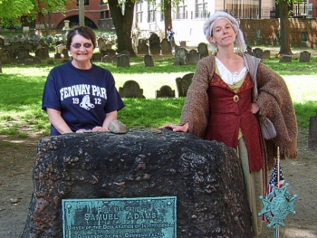
The second cousin of President John Adams, Samuel Adams is best known for his role as the Organizer of the Revolution. After failing as an owner of a beer brewery and as a tax collector - he proved too lenient when it came to collecting taxes from the poor - he finally found his calling as a political leader. Harvard-educated, he gained his political base by mastering the town meeting where he was the first to reason that being ruled by a government a month's sail away would inevitably fail. He was the main strategist for the patriots, calling their every move against every new Crown policy.
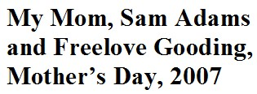
Adams was the first to make fun of himself and his
traditional bland Puritan clothing, an attribute that was immeasurable in winning over the local
townspeople whom he would meet every day as he made his rounds to the local taverns and ship yards. Cousin John described him as:

"...a man of refined policy, steadfast integrity, exquisite humanity, obliging, engaging manners, real as well as professed (poverty), and a universal good character, unless it should be admitted that he is too attentive to the public and not enough to himself and his family."

Adams led demonstrations against all Crown policies, created the Committee of Correspondence that led to the uniting of the other twelve colonies into a coordinated effort of protest and was the mastermind behind the Boston Tea Party. Adams was a member of both Continental Congresses and was a signer of the Declaration of Independence. After the war, Adams served as Lieutenant Governor and Governor of Massachusetts and was instrumental in getting the ratification of the U.S. Constitution. He died in Boston on October 2, 1803.

Jimmy’s Tangents:

•Sam Adams’ 1740 Harvard thesis could not have been more foreboding: "Whether it be Lawful to resist the
Supreme Magistrate, if the Commonwealth cannot otherwise be preserved."
•The emblem that is placed on every police car in Lexington contains the words Sam Adams spoke when he
first heard of the Battle of Lexington: “What a glorious morning for America!”
•#1 Trolley Tour joke: “The Beantown Pub (directly across the street) is the only pub in the world where you can
drink a cold Sam Adams…while staring at a cold Sam Adams.”.

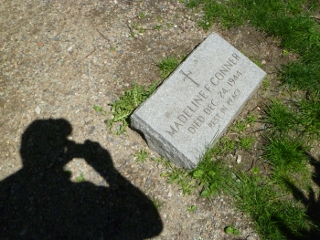Guest of Conner: If you turn towards Tremont Street, placing Sam Adams directly behind you, you will see across the path a relatively new granite gravestone with the name Madeline F. Conner. In 1985 the city-funded Historic Burying Ground Initiative (HBGI) did a survey of all sixteen burial grounds located in Boston proper. This included a recording of each and every headstone and tomb’s pertinent information (epitaph, condition, material, location) as well as identifying candidates for repair, improving/expanding pathways and updating information markers. Now if one were to look up the pertinent information recorded by the HBGI in regards to the grave of Madeline F. Conner one would encounter a mountain of…nothing. That’s because this headstone wasn’t there in 1985.
This wouldn’t be a surprise since technically burials in tombs ended in 1879 (reserved) and open ground burials (unreserved) even earlier. There seem to have been some exceptions for tomb burials since 1879 (look for Rhys Williams’ 2003 headstone near John Winthrop’s tomb at King’s Chapel Burial Ground) but that involved the deceased’s remains having been cremated. To add to the mystery is that Madeline Conner supposedly died on Christmas Eve 1944, forty-one years before the 1985 survey. Whether Madeline Conner was actually buried here in a tomb back in 1944, moved here after 1985, not buried here at all or (fill in the blank) remains unanswered, as well as who was responsible for placing the stone here.

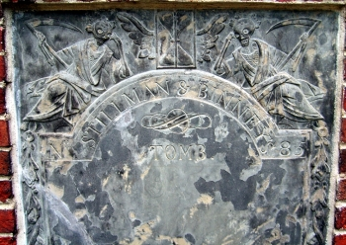Grim Peepers: As you make your way towards the tomb of Robert Treat Paine, I would like to introduce you to my favorite bit of funereal art here at the Granary: the Stillman & Binney Tomb (#85). As you can see for yourself the tomb’s slate marker features two Grim Reapers, both propping their upper bodies (well, skeletons) with their arms and looking both bored and disgusted. Since this tomb, like most, was actually built by an owner before their death, the Grim Reapers’ disposition seems to indicate an attitude of, “OK guys. We know you built this tomb ahead of your demise and, well, it’s a very nice one at that. But could you die already? See we’ve got places to go, bodies to retrieve… LOOK, WE DON’T HAVE ETERNITY! Uh…well…ok we DO have eternity but…OH, JUST DIE ALREADY!” (/sillyness)

Please feel free to scan the QR code to hear my silly fake advertisement for
“Stillman & Binney’s Headstone Headquarters.” (www.jimmystangents.com/stillmanandbinneyhq.mp3)

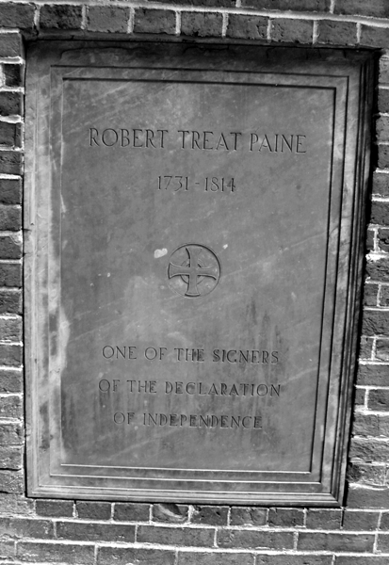ROBERT TREAT PAINE (1731-1814)

A native of Boston and a Harvard graduate, Paine entered the ministry in 1755 and served as a chaplain in the French and Indian War before changing course and deciding to study law. He was the prosecutor in the trial of the soldiers involved in the Boston Massacre. Paine attended the second Continental Congress and was one of only a few to sign both the July 1775 Olive Branch Petition (an attempt to make amends with Britain, it was rejected) and the Declaration of Independence. Paine served as the state's first Attorney General, helped draft the state constitution and served as a state Supreme Court justice for 14 years.

Jimmy’s Tangents:

•John Hancock, Sam & John Adams also signed the Olive Branch Petition
•According to Wikipedia.org…(read below for the exciting conclusion!)

No Tricks, All Treat: On March 7th of 2014, it was a blustery Friday and I was at my usual post on Tremont Street when this gentleman, like yourself, accepted the offer of the use of my guide. During some polite conversation he revealed to me that he was temporarily working in town for a few weeks and had some downtime and decided it was an opportune chance to pay respects to an ancestor buried here at the Granary. I asked him of whom he was related to and he replied, “Robert Treat Paine.” I replied, “Cool. One of the three signers of the Declaration of Independence buried here.” I then quickly explained where he could find him and off he went. About ten minutes later the gentleman returned and thanked me for the use of my guide and that he had indeed found his ancestor. Then the following exchange occurred:

Me: “Since you are related, sir, I’m not sure if you noticed it in my “Jimmy’s Tangents" section for Mr. Paine but, according to Wikipedia.org, actor Treat Williams is reputedly a descendent and namesake of Robert Treat Paine.”

Gentleman: “I’m Treat Williams.”

Me: “Oh… well…that’s cool…but I mean the actor Treat Williams.”

Gentleman: “I’m the actor Treat Williams!”

Me: “Oh…(reality finally registers) OHHH!!!”
We both had a good laugh and I mentioned how much I enjoyed the 1979 Spielberg-directed movie, 1941, that Treat starred in and how it was a classic case of a great movie that, while having been initially panned by critics, truly has stood the test of time and is a romping bit of fun. For a guy with a solid national profile after forty years in the competitive acting business- Hair, Prince of the City, Once Upon A Time In America, A Streetcar Named Desire,
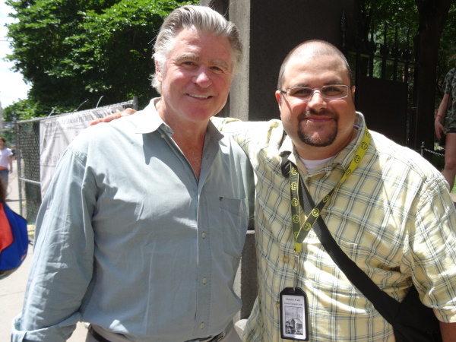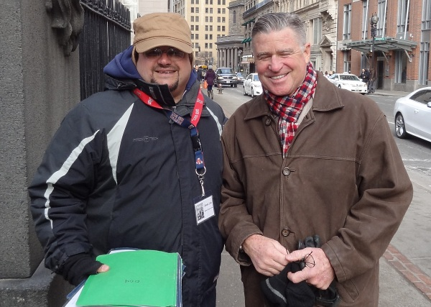 Everwood, 126 others! (according to IMDB) - Treat was super nice and offered to take a photo of us together (with the help of a fellow Bostonian’s hands) and posted it on his Twitter feed. A few months later, in the midst of summer, Treat made a surprise return, bringing along his lovely wife Pam. I showed him a quick glimpse of the write-up I had made and had him take a photo of the front page with the link to download my full guide (sound familiar?) and then I proceeded to describe to Pam the goofy scenario written here, except in this live, oral version, when I said Treat's name, I would also point at him for full silly effect. We all laughed heartily and, once again, Treat offered a photo, this time Pam doing the snapshot honors. After our good-byes, I realized that I once again had missed an opportunity to get a photo of Treat and his namesake together. Minor regret aside, it’s nice to be able to confirm that Treat's reputation as a classy, down to earth guy is well deserved. As my punny title says, “No Tricks, All Treat.”

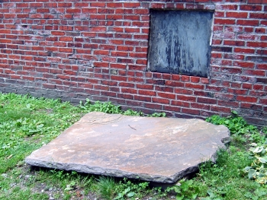Dr. Granary: If you continue up the path you will come to Tomb 96; take notice of the large slab of stone on the ground. While this flat stone indeed hides a hole that leads into the tomb, in February of 2007 it also hid $10,000. That’s because a large coin five inches in diameter in a black pouch was hidden under the slab's back edge. Finding the hidden coin and winning the money prize was to have been the reward for figuring out the 30th, and final, clue to a country-wide historical trivia contest “Hunt For More” sponsored by the makers of the Dr. Pepper soft drink: “You're hot on the trail, though the place may feel chilly. The coin rests by the name of a patriot at rest in Philly.” I’ll give you a minute to guess the answer.

The clue was released via the Internet at 3 AM and within a half-hour the front fence along Tremont Street was lined with eager treasure hunters. Boston Park Rangers arrived at their Boston Common headquarters around 6 AM only to find themselves inundated by angry cell phone calls from treasure hunters complaining that the burial ground was still closed. It was quickly determined that not only would the Granary not be opened to protect against any damage that a small army of treasure hunters digging through every nook and cranny might inflict, but local police needed to be alerted so that they could protect the graveyard from any overzealous participant that decided to simply take the next step and trespass.

Dr. Pepper officials cancelled the Boston portion of the contest, donated the $10,000 to a local charity, agreed to pay for the extra police detail, and vowed to never include Boston in any future contests without the full knowledge and approval of city officials.

Oh, I almost forgot. The chilly Philly patriot? Mr. $100 bill himself - Ben Franklin.
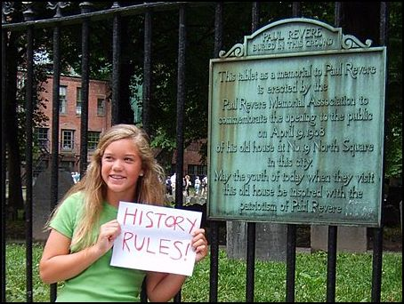
As the old Warner Brothers cartoon saying goes, “That’s All Folks!” I hope you enjoyed your visit here at the Old Granary. Feel free to visit my website (jimmystangents.com) where you can download an exact copy of this guide in electronic form (pdf) for free. I am currently adding a variety of Boston historical-related content to enhance your next visit here in “Beantown.”

That being said, I would like to wish you a wonderful rest of your stay here in Boston and safe travels back to your corner of the world.

Copyright © 2007-2023 by James W. Cole

